Economy of Scale: A Pernicious Myth in the Human Services

In the twentieth century, human services in America rejected large scale segregation of citizens with disabilities. This trend was supported by a body of evidence that may well be the most complete and conclusive ever compiled. Institutional settings were far more costly, and produced far worse outcomes, than any of a variety of small community-centered family-like settings.

Conroy (2011) has suggested that many who supported institutional models relied on an ill-informed belief in the “Economy of Scale” – that putting hundreds, or thousands, of citizens together, in one place, would enable greater cost-efficiency than a dispersed system of small homes. This belief is not only flatly contradicted by empirical evidence, but it makes it seem as though the institutional advocates did not finish reading their basic Economics textbooks.

Directly after any textbook discussion of “Economies of Scale” is a discussion of “Diseconomies of Scale.” Organizations become more efficient up to a certain size, depending on the type of organization, and then become less and less efficient as they get bigger. Shown graphically, the full model of size and efficiency looks like this:

As a manufacturing organization grows, the cost per widget goes down – but only up to a certain point – and then “Diseconomy of Scale” sets in and the cost per widget goes up when the organization gets too large.

In the human services, the real “product” is quality of life. And in the realm of residential supports for people with disabilities, the size “break point” appears to be at approximately size six. The largest databases in America clearly show declining qualities of life, in every dimension, when residential size increases. From the National Core Indicators project, here are two graphs to illustrate this extremely consistent finding.

Percent Saying Opportunities for Choicemaking
“I Do NOT Like My Home” By Size of Home
By Size of Home

As the size of the home increases in this national data set (which covers more than 25 states and tens of thousands of people), NOT liking the home goes up, and self-determination and independence go down. In other large data sets, evidence is readily available showing that loneliness increases in the larger settings, while nearly all other indicators of quality of life decrease.

But do we really save any money in the larger homes? Here is a compilation of real Pennsylvania data. On the left is the rising cost per person in our institutions – now at about $220,000 per person per year – which is the most costly human service in history – in this nation or any other. On the right is real Pennsylvania data on the cost of community group homes from 1992, just 5 years after the famous Pennhurst deinstitutionalization was completed.
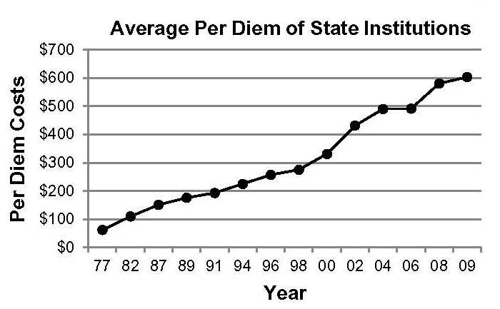

On the left, we see a picture of costs rising out of control in Pennsylvania’s institutions. On the right we see clear evidence that the smaller group homes did NOT cost more per person than the large ones.

The institutional model was soundly rejected by some of the strongest and clearest evidence in the history of the social sciences. Any move to reconsider this trend, perhaps the most successful American social change of the Boomer generation, is so ill-advised as to be counter to all principles of good government – including effective use of limited tax dollars.

Prepared by the Center for Outcome Analysis, 2012.

