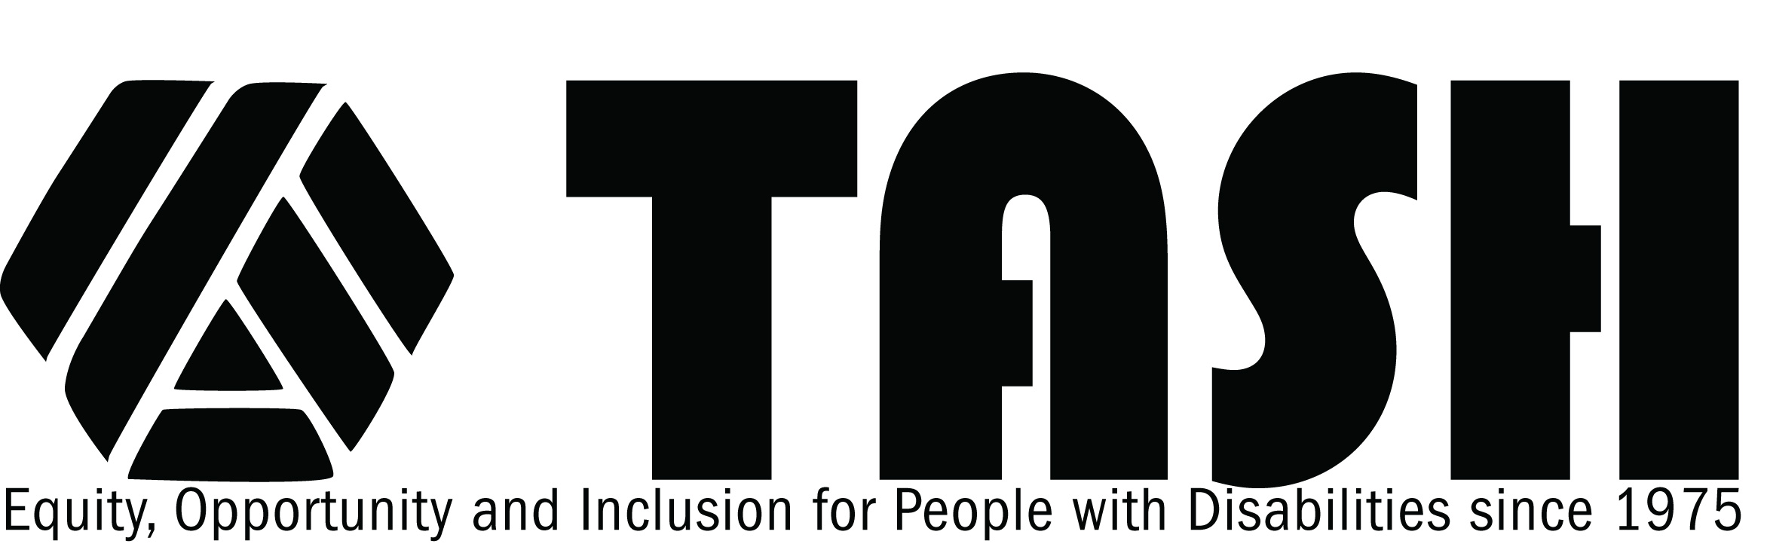

TASH Resolution on Quality Inclusive Education

Statement of Purpose
TASH supports a vision of high expectations for all students and a commitment to a set of learning goals or standards that are strong, clear, understood, and put into practice. TASH values and supports diversity and recognizes both the legal right to and the reciprocal benefits of inclusive education.
Rationale
A high quality public education is the right of all school-age children and youth. Students with disabilities have a right to be educated in the regular education classroom with their non-disabled peers. Education in regular education settings implies more than just physical presence; it includes access to the curriculum that is taught in the regular education classroom.
Students with disabilities are entitled under the Fourteenth Amendment of the U.S. Constitution, federal civil rights law, including Section 504 of the Rehabilitation Act of 1973, the Individuals with Disabilities Education Act, and the Americans with Disabilities Act, their respective state constitutions, and state law, to be free from discrimination and to be provided equal educational opportunity to learn what all other students are expected to learn. Indeed, the IDEA, Section 504, and the ADA all require, as they have from their inception, that students with disabilities must be educated in regular education settings to the maximum extent appropriate in light of their needs, and prohibit their exclusion unless education there cannot be achieved satisfactorily even with appropriate supplementary aids and services. Courts have recognized the rights of students with disabilities to be educated in the regular education classroom with their peers without disabilities under these laws. A school district proposing to remove a child from the regular education classroom has the burden of proving that such removal - whether partial or total – is necessary because education cannot be reasonably accomplished with the use of supplementary aids and services and/or modifications to the regular education curriculum.
Yet, despite clear legal rights and numerous judicial rulings, students with disabilities continue to be isolated and separately educated, provided a diluted and inferior education, and denied meaningful opportunities to learn. As recently as 1997, the United States Congress in reauthorizing and amending the Individuals with Disabilities Education Act, admitted in findings codified at 20 U.S.C. 1400(b)(4) that: "...implementation of this Act has been impeded by low expectations, and an insufficient focus on applying replicable research on proven methods of teaching and learning for children with disabilities...." . This, in spite of more than 20 years of research and experience providing evidence that the "education of children with disabilities can be made more effective by having high expectations for such children and ensuring their access to the general curriculum to the maximum extent possible." 20 U.S.C. 1400(c)(4).
Because of this long history of exclusion and discrimination, many students with disabilities have been denied access to the general education curriculum, have been excluded from the school they would attend if not for their disability, and have been unnecessarily isolated from their age appropriate peers who are not disabled.
THEREFORE BE IT RESOLVED, THAT TASH, an international advocacy association of people with disabilities, their family members, other advocates and people who work in the disability field, affirms that all students with disabilities shall be provided a quality, inclusive education that assures full and meaningful access to the general education curriculum. To achieve such an education, support services must be provided as needed, programs and curricula must be modified as needed, and students must receive such supports, supplementary aids and services as are necessary in an inclusive setting. The expectation shall be that every school community shall provide a quality, inclusive education for all students with disabilities that is predicated on a shared vision of high expectations for all students and a commitment to a set of learning goals or standards that are strong, clear, understood, and put into practice.
Local, state, provincial, regional and federal governments, as well as all related organizations, stand accountable for the development and maintenance of educational opportunities for all students that are inclusive and ultimately effective. All governments must be urged to enforce vigorously, at all levels, legislation that assures quality, inclusive educational practices.
Fully inclusive schools are characterized by the following components which are overwhelmingly supported by research and documented experience:
General Components
- A single set of standards that embraces all students; a broad umbrella of standards that encompasses supplemental educational needs, including functional or independent living skills;
- Teaching which uses heterogeneous groupings and a variety of age-appropriate instructional strategies based upon students' learning needs and which emphasizes learning strategies designed to enable students to meet the standards or components of the single set of standards;
- High expectations for all students;
- Teachers who treat each student as a uniquely important individual and who are knowledgeable about research based practices that assist students with diverse learning needs to learn;
- Program philosophy which emphasizes the value of diversity, multiculturalism, social justice, and belonging for everyone;
- Access for all students to campuses and classrooms, including co-curricular and extra-curricular activities, that are free from prejudice and other physical and psychological barriers;
- Comprehensive, sensible and culturally competent curricula which are effective for the full range of learners; and,
- Opportunities for all secondary school students to participate in community and/or job skill development programs which do not impact negatively on participation and full membership in their high school community.
Assessment
- Thorough analysis of the learning needs of all students;
- Broad use of unbiased and culturally sensitive assessment procedures that enhance students' strengths and assist in the identification of their needs;
- Accountability for achievement which is based, in part, on each student's personal potential and educational experience;
- Full participation in all state or districtwide assessments to enable students with disabilities to participate in the accountability system; and,
- Measuring whether schools and local educational agencies are making progress toward enabling all students to meet challenging standards set for all students and holding schools and districts accountable, in part, through public reporting requirements.
Communication
- Emphasis on the importance of family involvement and home-school communication structures that are culturally responsive and which empower families;
- Conscious creation of a strong sense of community and fostering mutual respect and support among education staff, parents, and students;
- Collaboration among teachers, other personnel, family members, students and peers to plan and deliver educational services; and,
- Well-delineated processes for problem-solving as defined by the family, student and classmates.

Staff Development
- Teacher training programs at the inservice and preservice levels that are inclusive and collaborative of general and special education teachers so that all teachers will be prepared to teach all students effectively;
- Appropriate staff development programs for administrators, teachers, family members, paraprofessionals, and related services staff which will develop the necessary understandings, skills and behaviors; and,
- Professional development designed to ensure that teachers of students with disabilities are knowledgeable about research based practices for effectively teaching students to high standards.
Supports
- Provision of all necessary and appropriate supports and services to provide all students with opportunities for success;
- Access to curriculum accommodations and modifications which allow students to access core curriculum and assessment and accountability systems;
- A broad range of personal support services (e.g. speech, reading, occupational therapy) which are closely coordinated with the general education classroom's goals and activities and which are provided in general education settings;
- Instructional and assistive technologies that foster self-determination, participation, and choice;
- Creative ways to allocate special and general education resources, with funding obstacles removed; and,
- The use of positive behavioral supports that are based on functional assessment of problem behavior.

Adopted December 1988
Revised December 1993
Revised March 2000

