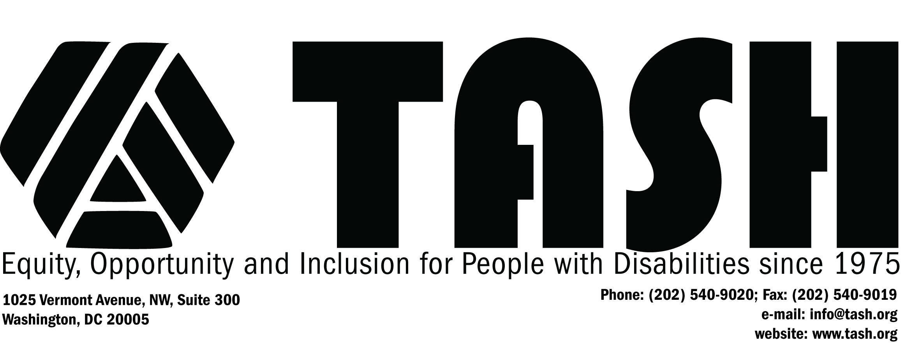

TASH Resolution on Positive Behavioral Supports

Statement of Purpose
The purpose of this resolution is to affirm the rights of people with disabilities to receive interventions that are respectful, free of pain and produce positive change for the individuals.
TASH's resources, expertise and advocacy are dedicated to the development, implementation, evaluation, and dissemination of positive educational and behavioral support practices that are appropriate for use in typical community settings and are consistent with the commitment to a high quality of life and personal satisfaction with life for individuals with severe disabilities.
Rationale
Educational and other habilitative services must employ instructional and support strategies which are consistent with the right of each individual with severe disabilities to effective support without compromising their equally important right to freedom from harm. Access to strategies that humanely assure physical safety is an important part of this right.
Current research and practice have demonstrated the practical efficacy and benefits of functional behavioral assessment and positive interventions for helping to resolve the challenges of problem behavior affecting people with severe disabilities.
Individuals with severe disabilities have the right to equal access to medication, emergency, and safety procedures available to individuals no labeled with a disability, according to legal, regulatory, personal, family, and community standards.
THEREFORE BE IT RESOLVED, THAT TASH, an international advocacy association of people with disabilities, their family members, other advocates and people who work in the disability field calls for the cessation of the use of any educational, psychological, or behavioral intervention that exhibits some or all of the following characteristics:
- dehumanization through the use of procedures that are normally unacceptable in community environments for person who are not labeled with a disability;
- obvious signs of physical pain experienced by the individual;
- physical injury and potential or actual side effects such as tissue damage, physical illness, and/or severe physical or emotional stress;
- effects which would require the involvement of medical personnel, and/or other health care authorities;
- ambivalence and/or discomfort on the part of the individual, family, staff, and/or caregivers regarding the use of interventions or their own involvement in such interventions;
- signs of community or peer repulsion or stress from witnessing procedures that are widely divergent from the standard of acceptable practice;
- the use of physical restraint for any purpose other than crisis intervention to protect individuals from imminent harm; and/or
- the use of sedative drugs (chemical abuse or restraint) for the sole purpose of behavior management.
BE IT FURTHER RESOLVED, THAT TASH, calls for all persons with severe disabilities to have access to approaches that enable them to positively affect their lives in ways that are meaningful to them.
Therefore, educational and other support services applied in situations involving problem behavior must:
- be developed in collaboration with the individual in a respectful and culturally sensitive manner that facilitates self-determination;
- be based on a functional behavioral assessment of the internal and external variables that may be affecting the person's behavior; and
- use the findings of the aforementioned analysis to develop constructive and comprehensive approaches -- including medical, education, communicative, and environmental interventions -- to assist the individual to address the circumstances that adversely affect his or her behavior. Further, supports should be provided in a manner that maximizes access to, and participation in, the full range of typical home, school, and community settings, in order to maximize the individual's personal well being.

Adopted October 1981
Revised November 1986
Revised March 2000

