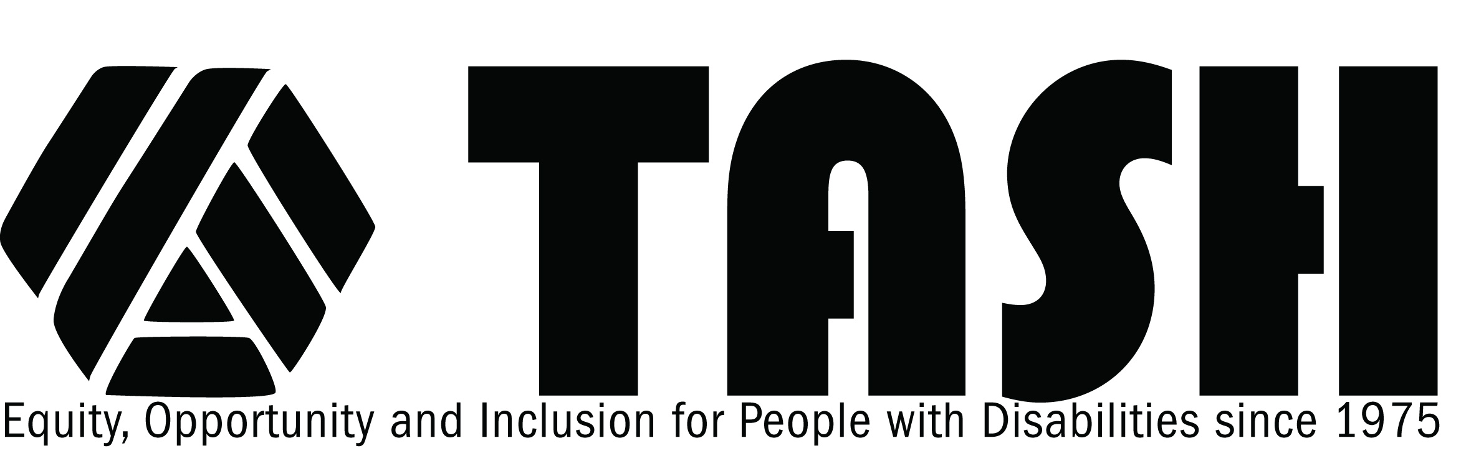

TASH Resolution on Augmentative and Alternative Communication Methods and the Right to Communicate
Statement of Purpose
The right to communicate is the means by which all other rights are realized and is, in itself, a basic human right. All people communicate and have the ability to make and express choices, although it may take a patient and skilled person to elicit and interpret such expression. In the name of fully realizing the guarantee of individual rights, we must ensure:
- that all individuals have a means of communication which allows their fullest participation;
- that people are given access to assessment in a range of various communication methods;
- that people can communicate using their chosen method in all of the settings in which they spend time; and that their communication is understood and heeded by others.
Where people lack an adequate communication system, they deserve to have others try with them to discover and secure an appropriate system. No person should have this right denied because he or she has been diagnosed as having a particular disability. Access to an effective means of communication is a free speech issue.
Rationale
Access to Communication. All persons with disabilities should be provided therapy and training directed toward permitting them to communicate freely. All people with communication disabilities should be given the full opportunity to use the method of augmentative and alternative communication that works best for them. "Access" includes: a) access to assessment to judge the suitability of a range of methods, b) access to training in the method found to work best for the individual, and c) access to needed equipment and trained support people both in the short term during training, and in the longer term for continued use on a daily basis in all of the settings in which an individual spends time so the individual can use his/her preferred communication method across environments.
Education. Instruction in communication is an essential element of the education of people with communication disabilities. People using augmentative or alternative communication must be given any assistance necessary in order to communicate with others at school or in their educational program. Any equipment, training or staffing necessary to enable communication to take place must be supplied, both to that person and to those with whom he or she wishes to interact on a regular basis. The collaborative education team must ensure that all such communication equipment, or comparable equipment, follow the person to his/her other settings and when transitioning to post-school environments.
Freedom to Communicate. People with communication disabilities must be allowed to use the communication system of their own choice in all communication interactions in any setting. No person should be able to veto the use of another person's preferred communication method and in any instances where such use is forbidden, there should be recourse to the individual and his/her family members through the legal and protective systems.
Facilitated communication. Facilitated communication is one of many augmentative and alternative communication techniques that is used by some individuals who cannot speak or whose speech is limited. The method involves a communication partner, typically called a facilitator providing physical and emotional support as the person points at pictures, letters, words, or other symbols.
Facilitated communication is controversial. In some research studies, individuals using facilitation have not demonstrated that they were able to convey their own thoughts through the method. Some studies have revealed that individuals have been influenced by or have picked up on cues from their facilitators. In other studies, individuals have demonstrated the ability to express their own ideas and to do so without influence or cue seeking. Many individuals with disabilities have progressed from supported typing to independent typing.
The question of authorship can become particularly controversial when the subject of what has been communicated concerns sensitive issues. Such topics may include, for example, preferences about living arrangements, allegations of abuse, and selection of personal assistants. As with all other methods of augmentative and alternative communication, TASH supports access to assessment to determine if this method of communication works for a particular individual , access to training in the method for both the individual and the facilitator, and, if demonstrated to be a successful method for the individual, access to the method and a trained facilitator for use in the long term in all of the settings in which an individual spends time. TASH encourages careful, reflective use of facilitated communication. TASH encourages facilitators to work in collaboration with individuals with severe disabilities to find ways of monitoring authorship when using facilitation. To this end, TASH encourages use of multiple strategies, including, for example; empirical research methods (qualitative and quantitative) and transitioning to independent typing.
Legal Issues. People using augmentative communication must be permitted to use the system that works best for them and that they prefer in court as in other settings. Any person using a communication strategy requiring the involvement of another person to receive and relay their communication must be permitted to use the partner of his/her choice in court. Each state's protection and advocacy system should develop the resources needed to support such full participation in the legal process.
Presumption of Competence in Decision-Making and Advocacy. People are presumed to have an active interest in decisions affecting their lives on a short-term and long-term basis. In planning or decision-making on a person's behalf, that person's participation must be ensured regardless of the formal communication modalities used. This may include the involvement of allies, advocates and communication partners before and after meetings, and may also include the involvement of a "communication ally" during the course of the meeting.
THEREFORE BE IT RESOLVED, THAT TASH, an international advocacy association of people with disabilities, their family members, other advocates and people who work in the disability field:
- regards access to augmentative and alternative means of expression an individual right.
- encourages its membership to become informed about the complexities of augmentative and alternative communication methods, training, and practice and to stay informed of new research and practice related to communication methods.
- encourages rigorous and ongoing training for people who provide training and support in all methods of augmentative and alternative communication.
It is important not to silence those who could prove their communication competence while using augmentative and alternative means of communication or any other method of expression.
ORIGINALLY ADOPTED NOVEMBER 1992
REVISED December 2000

