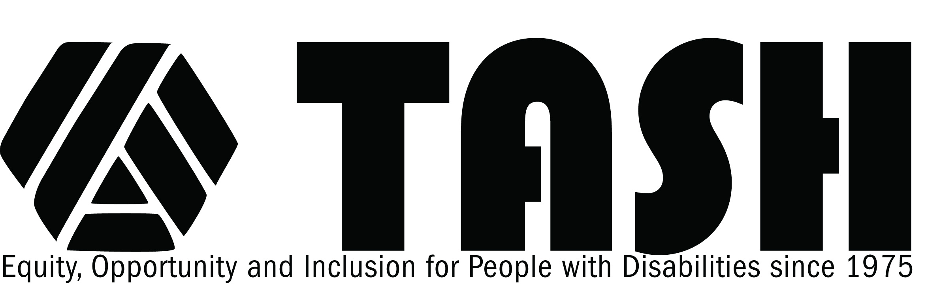

TASH Resolution on Preparation of Related Services Personnel for Work in Educational Settings

Statement of Purpose
University programs that prepare related services personnel such as occupational therapists, physical therapists, speech/language pathologists, psychologists, and school counselors share responsibility for ensuring that the needs of students with disabilities are met in educational settings. TASH recognizes and respects the standards that each profession sets for accreditation of academic programs and preparation for professional licensure. The purpose of this resolution is to establish complementary guidelines that focus specifically on preparation of related service providers to meet the needs of students with disabilities.
Rationale
TASH’s Resolution on Inclusive Quality Education is grounded in principles of equity and social justice for all. It clearly states the educational and moral imperative that students with disabilities belong with their same-age peers without disabilities in general education classrooms, and that they receive the supports and services necessary to benefit from their education in general education settings. The Resolution on Teacher Education asserts that universities share responsibility for ensuring that the educational needs of students with severe disabilities are met in general education settings with their nondisabled peers, and establishes guidelines for the preparation of teachers. The Resolution on Related Services affirms the important roles of professionals such as occupational therapists, physical therapists, speech-language pathologists, and counselors in the process of individuals with disabilities becoming fully-included members of society.
In conjunction with these resolutions, it is TASH’s position that programs that prepare related service providers must be inclusive and collaborative, so that (a) related service providers are prepared to meet the needs of all children and youth with disabilities through collaboration and effective intervention strategies, and (b) the expertise required to meet the individualized needs of each student can be accessed easily on education teams. TASH’s position is based on the beliefs that programs preparing related service providers should reflect research and ongoing discourse about effective practices in both services for students with disabilities and programs preparing related service providers.
Therefore, be it resolved, that TASH, an international advocacy association of people with disabilities, their family members, other advocates, and people who work in the disability field, affirm our commitment to support the continuation and advancement of programs that prepare related service providers, and advocate for programs that:
  - are based on knowledge of what constitutes effective educational practices;
  - focus on access to, and the acquisition of, skills that are age- and/or grade-related;
  - situate services in general preschool settings or other integrated environments for preschool-aged children, in general education settings for school-aged students, and in integrated, natural community environments for young adults; and
  - incorporate the following guiding principles.

Guiding Principles for Preparation of Related Services Personnel
- Most of the professionals who provide related services in educational settings have been prepared, at the entry level, to meet the needs of broader populations of children and adults with disabilities, in settings ranging from hospitals and clinics to home and school. In developing this broad base of knowledge in their field, all related service providers need to be prepared to:
  - establish positive, respectful, and culturally-responsive relationships with a diverse population of people with disabilities and their families, including: (a) those with a range of abilities and needs; (b) those from a variety of racial, ethnic, cultural, linguistic, and economic backgrounds; and (c) those from a variety of family configurations and support systems;
  - collaborate with families in order to strengthen families’ roles and ensure that they have meaningful opportunities to participate in the education and/or (re)habilitation of their family member with disabilities at home, at school, at work, and in the community;
  - collaborate with teachers and other service providers, including those who provide personal supports, education and related services, adult services, and other community services, to plan and provide individualized services and supports;
  - conduct assessments in everyday activities and routines in natural environments, blending their expertise and perspective with professionals from many disciplines;
  - employ a collaborative planning process with the person with disabilities and his/her family that results in increased voice, independence, interdependence, and control over the selection of valued life outcomes (e.g., self-determination, person-centered planning);
  - design and use meaningful, learner-centered, and non-intrusive intervention methods that respect personal dignity and individual privacy;
  - provide individually-appropriate, outcomes-oriented intervention to assist each person with disabilities to have meaningful involvement within all aspects of community life, including living, being educated, working, and enjoying leisure time in the community to the greatest extent desired by that individual;
  - provide services and supports within the everyday settings and activities that match the chronological age and interests of each consumer, including home, community, and age-appropriate general education settings and activities;
  - adhere to the principle of "only as special as necessary" when designing services, so redundant, unnecessary, and unwanted services and supports are not provided;
  - provide services and supports that prepare students for meaningful participation in future integrated environments, including home, school, and community; and
  - implement an annual professional development plan that maintains competence and continues growth in best practices for educating students with disabilities in inclusive settings.
- Advanced level preparation programs should provide opportunities for in-depth study of and specialization in services and supports for children and youth with a full range of disabilities in educational settings that reflect current effective practices and theory, as grounded in careful inquiry and analysis. Advanced level programs and continuing education should include:
  - blending of research and theory into assessment and effective intervention strategies that can be used within the full range of an individuals’ activities and environments (e.g., school, home, community, work place), with particular emphasis on participation in everyday activities and routines in general education settings;
  - utilization of current effective practices for collaborative teamwork in educational settings, to conduct assessment, establish goals and objectives, and plan intervention in ways that respect the holistic needs of children and youth with disabilities and the contributions of other team members, including the family and the student to the fullest extent possible;
  - preparation to train, supervise, and evaluate paraprofessionals and volunteers to support children and youth with disabilities in ways that facilitate each student’s participation in the full range of educational activities and promote social interactions with students without disabilities while addressing the needs that require provision of related services;
  - preparation to encourage and guide natural supports from children and youth without disabilities (a) to accept and respect their classmates with disabilities as individuals with differing voices, strengths, abilities, and contributions, and as valued members of their educational community; (b) to support participation of classmates with disabilities, and (c) to assist them, when appropriate, to achieve their goals;
  - preparation to advocate for students with disabilities and their families through participation in due process, policy development, and legislation at the local, state, and federal levels; and
  - preparation of professionals who engage in reflection and life-long learning in relation to educational services for children and youth with disabilities within the school community.
- In relation to effective practices in personnel preparation activities, programs must reflect research-supported practices and innovations that result in effective related service providers who are reflective life-long learners. Such practices include:
  - a coordinated set of courses, activities, and field-based experiences, accompanied by on-going mentoring relationships with 1-2 program faculty, which facilitates the continuous development of professionals from an emerging, to a proficient, to a mastery level of expertise (instead of a set of isolated courses or experiences);
  - authentic portfolio-based assessment activities that support the development of related service providers who collaboratively team and problem-solve with others, in order to provide effective and personally meaningful services and supports for students with severe disabilities in inclusive settings;
  - co-teaching involvement of people with disabilities and family members in content courses where students would benefit from presentation of content within the context of person-centered and family-centered perspectives;
  - a close link between content courses and field-based experiences, so that field-based experiences reflect the use of content as it is addressed in courses; and
  - on-going collaborative support of new related service providers through the induction process by both program faculty and school district personnel.

Adopted March 2003

