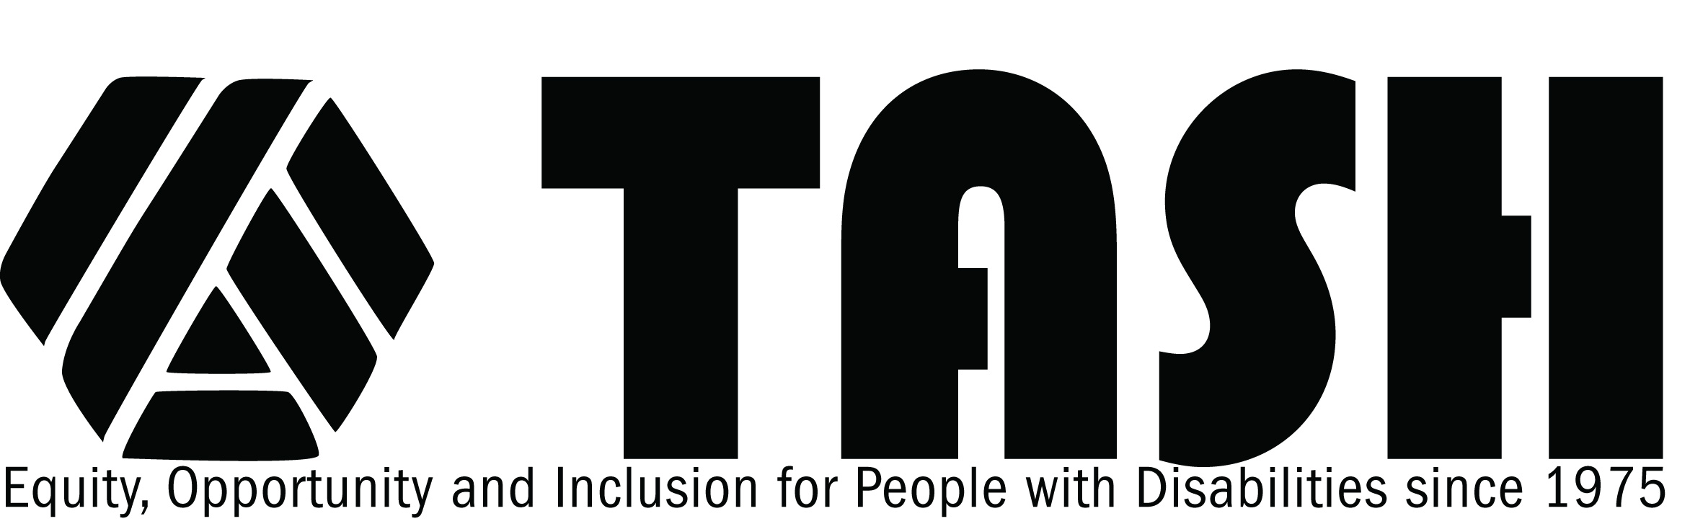

TASH Resolution on Diversity and Cultural and Linguistic Competency

Statement of Purpose
We (the Disability Community organizations signed herein) recognize that the celebration and valuing of diversity is instrumental to unbridling the full potential of every individual. The appreciation of diversity – those differences that make us unique – can be personally, organizationally, and culturally transformative. The acknowledgement, support and advocacy of ethnic and cultural diversity, particularly in the disability community, is essential to achieving parity, attaining optimal life affirming outcomes and building community cohesion. Individuals of color and individuals expressing other characteristics of diversity must be supported by public and organizational policy and practices to attain full inclusion in policy-formulation, program design, funding decisions, research, and other activities that construct and sustain our vision and our values.

Cultural and linguistic competency is a prerequisite to fully embrace diversity. This
developmental process enables effective cross-cultural collaboration and enhances
organizational capacity through its permeation in every aspect of organization/community activity.

Rationale

We firmly uphold the basic right of individuals of color and others with defining diverse
characteristics to fully participate in all aspects of the disability community and in our
society. We are all enriched by this participation and, ultimately, as diversity is understood and valued and cultural competency embedded, appreciation of individuals with significant disabilities will be enhanced by their contribution to their communities and our society.

Examination of our membership structures, conferences, and publications currently reveals a low level of participation by individuals of color. This is true of disability organizations in general. In contrast, health prevalence data from the Centers for Disease Control and Prevention (CDC) document high prevalence rates of intellectual and developmental disabilities in many communities of color. Disproportionality of students of color in special education is a persistent concern. A lack of access to and equity in disability services contributes to higher poverty rates, lower post-secondary education placements, and poor health outcomes for individuals of color. These factors necessitate a public and unequivocal commitment by the disability community for self-examination of the expression of diversity within our organizations; for promotion of diversity in the disability community and our society; and enhancement of cultural and linguistic competency.

THEREFORE BE IT RESOLVED, THAT WE, organizations of the disability community, comprised of people with disabilities, family members, researchers, professionals and other advocates and people who work in the disability field, believe that diversity and cultural and linguistic competency within the disability community is a critical and shared priority fully consistent and integral with our missions. As part of our commitment to diversity and cultural and linguistic competency, we have established Board Committees on Diversity to provide guidance in this effort. Furthermore, we will promote cultural and linguistic competency through the following:

- Establish and annually review our progress towards cultural and linguistic competency (e.g., Board and general membership, conference participation, promotion of research topics, appropriate materials, etc.);
- Dedicate resources to the attainment of our organizations’ cultural competency goals;
- Organize and present content in our publications, conferences, websites and webinars in a culturally and linguistic appropriate manner;
- Develop training tools and conduct trainings on cultural competency;
- Collaborate with each other and other segments of the disability community to promote policies and practices that sustain cultural and linguistic competency.

Progress towards achieving these goals requires steady and persistent effort. We seek to
inculcate these values into all aspects of our work, our deliberations, and our advocacy. The pursuit and incorporation of diversity and cultural and linguistic competency is merely recognition of the heterogeneity of individuals with significant disabilities and the
composition of our society. Consistent with the experience of other civil rights and disability rights achievements, attaining and sustaining diversity and cultural and linguistic competency benefits everyone in our disability community and in our society. In the same way curb cuts help individuals who use wheelchairs as well as individual who use strollers, appreciation and expression of diversity helps individuals with significant disabilities of all cultures and backgrounds make contributions to the greater community. Our commitment to these values not only addresses disparities confronting communities of color, it also strengthens and enriches our organizations, the disability community, and our society.

Signed

American Association on Intellectual Developmental Disabilities
Autism Society
The National Down Syndrome Congress
The National Council on Independent Living
The National Youth Leadership Network
TASH

Approved October 2010

