Membership
Looking to be part of a community of practice based on values and innovative support strategies? Want to join a growing movement of professionals and advocates committed to positive and lasting change in the lives of people with disabilities? TASH is for you!

Download a membership application
-or-


For the past 37 years, TASH members have addressed issues of equity, opportunity and inclusion for individuals with significant disabilities. The remarkable contributions of TASH members have advanced advocacy, research and professional practice, and paved the way for better lives in the community for people with disabilities. Today, amidst new and age-old challenges, we’re working to continue to advance inclusive communities and support individuals with disabilities in all aspects of their lives.
TASH is a values-based organization that believes all people deserve to be participants in their communities, build lasting relationships with peers and neighbors, and access the opportunities promised to us all. By joining TASH you help us move closer to that vision.
The following is an overview of TASH membership levels. Descriptions of each level, along with additional information on benefits, are below.
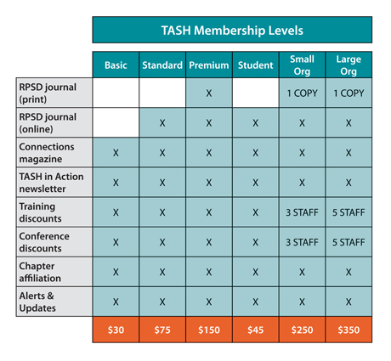

TASH Membership Levels

Basic Membership $30
Includes access to current issues of Connections magazine and back issues; TASH in Action bi-weekly newsletter; training and education discounts for webinars, publications and more; discount to TASH Conference registration; affiliate with state/regional chapters; important advocacy alerts and updates.

Standard Membership $75
Includes all benefits of Basic membership, plus online access to current issues of the TASH research journal, Research and Practice for Persons with Severe Disabilities, as well as back issues of the journal.

Premium Membership $150
Includes all the benefits of Basic and Standard membership, plus print delivery of each new issue of the TASH research journal, Research and Practice for Persons with Severe Disabilities.

Student Membership $45
Includes all benefits of Basic membership, plus online access to current issues of the TASH research journal, Research and Practice for Persons with Severe Disabilities, as well as back issues of the journal.

Small Organization Membership $250
Includes all benefits from Premium membership, but intended to share with multiple staff. Receive discounts to all training and education offerings for up to three staff, along with TASH Conference registration discounts for three staff.

Large Organization Membership $350
Includes all benefits from Premium membership, but is intended to share with larger staffs. Receive discounts to all training and education offerings for up to five staff, along with TASH Conference registration discounts for five staff.

TASH Member Benefits
Research and Practice for Persons with Severe Disabilities (Print)
Benefit includes all new print editions of TASH research journal, which publishes quarterly. View a sample article.
Research and Practice for Persons with Severe Disabilities (Online Access)
Benefit includes online access to current and archived editions of TASH research journal. Archive editions available from 1998 to present.
Connections (Online Access)
Benefit includes access to all new editions of Connections, the magazine written by and for TASH members. Online access is also provided to the expanded archive of Connections, which includes individual articles searchable by volume, name, author and keyword. View a sample of issue of Connections.
TASH in Action
Benefits includes receipt of bi-weekly e-newsletter that covers TASH news, chapter news and events, and current topics and stories from around the disability community. TASH in Action is delivered every other Tuesday. Preview a sample edition of TASH in Action.
Training Discounts
Benefit includes member discounts for webinars, training opportunities and publications. You can view a list of current webinars here.
TASH Conference Discount
Benefit includes member discount for annual TASH Conference registration, as well as other events where applicable. Learn more about the TASH Conference.
Chapter Affiliation
Benefit includes automatic enrollment with TASH Chapter in state/region or residency. TASH Chapters organize at the state and regional level to tackle area challenges, and hold events and opportunities for training and professional development. Find a chapter near you.
Advocacy Alerts and Updates
Benefit includes exclusive alerts on advocacy opportunities, reports, resources and other updates from TASH.

