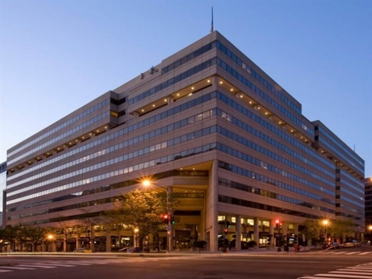

[Sidebar Title]

TASH  
1875 “Eye” Street, NW, Suite 582

Washington, DC 20006