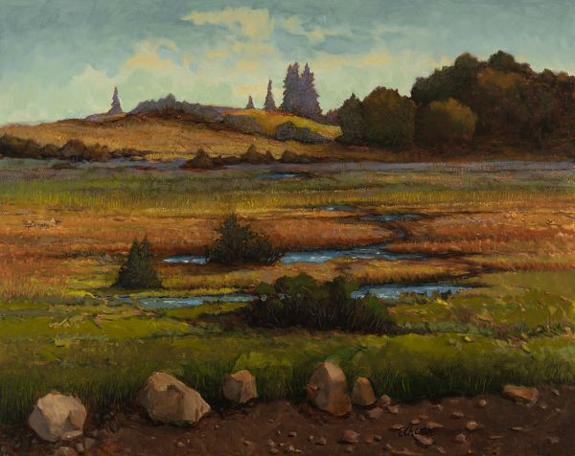

Tom Chesar

"Rambling About" by Tom Chesar will be on display in New Hope through Sept. 15.

**By**[**Janet Purcell | For The Times of Trenton**](http://connect.nj.com/staff/njopurcell/posts.html)

Landscape painter William Langson Lathrop founded a summer art school in New Hope in 1898. He -- and the beauty of the Bucks County landscape -- began drawing other landscape painters to the area. Thus began the legacy of landscape painting that continues today in Bucks County.

Honoring that time-tested tradition, is the 2019 Legacy Exhibition currently on view at the New Hope Arts Center. The exhibit features more than 60 recent works by Tom Chesar and Richard Lennox.

Both artists have anchored their successful long careers on representational landscapes that are infused with their own perceptions and interpretations. Lennox works primarily on boards using oil pigments while Chesar paints in oils, acrylics, gouache and egg tempera.

“Painting for me is about light, memory, and the senses. It is more about construct rather than naturalistic rendition,” Lennox says on his website, [richardlennoxart.com](https://www.richardlennoxart.com/).

In many of Lennox’s paintings we are looking down upon houses and outbuildings, their angled rooftops varying in color and size. They are always portrayed in close proximity to one another emitting a sense of insular community. Often they are nestled among trees as in “Roofs and Nature #1 and #2” and seem to be a part of nature that surrounds them snug and protected.

In “Outpost” Lennox offers a view of a group of roofs of buildings standing in a hollow along the side of a country road that seems to drop off. Without painting it in, Lennox convinces us the road dips sharply down. There is no sky showing. You just see evergreens climbing a distant hill to the top of the picture plane. This is an especially difficult concept to convey in landscape painting and Lennox does it successfully.

Of the 31 paintings Lennox has included in this exhibition is “On the Edge,” a 10-by-22-inch horizontal painting where a cluster of steep-roofed buildings stands on the edge of a field on a low horizon. Strong sunlight brings some of the buildings in sharp focus while others are seen in deep shadow. There is a captivating silence about this painting. Although a group of buildings might suggest activity going on in and around them, it is not so in this painting, nor in many of Lennox’s works. Although they portray landscape, they could also be called still life.

Tom Chesar’s painting, “Barn in the Hills” pairs well with Richard Lennox’s works. In this we also see farm buildings clustered in the landscape with strong light glancing off a steeply pitched barn roof. However where Lennox often chooses to present his buildings in a low horizon landscape, Chesar nestles his barns in this painting in a landscape with rolling hills rising in the distance and showing only a narrow band of sky.

And Chesar ventures farther afield to the “Ringoes Train Station,” to “Island Beach State Park,” and on scenes in Maine. Using gouache pigments, Chesar portrays a sense of time suspension in “Lobster Shack” as the lobsterman’s boat waits in the water beside the shack. Lobster pots are stacked and color-coded buoys are piled on the grass. You almost expect to see the lobsterman emerge from his tall white shack heading toward his waiting boat.

But traveling back from Maine, Chesar shows us his beloved Delaware Valley landscapes in many seasons. In “Winter Solitude” we see a barn standing behind drifted snow mounds. As he points out on his website, [tomchesar.com/thumbnail_list.php](https://tomchesar.com/thumbnail_list.php), “the warm colors of the barn glow in the surrounding quietness.” In “Waiting For Spring” he turns to a still life of a bird house, clay pots and a watering can to evoke our thoughts of spring landscape.

“Rambling About,” a magnificent landscape, has a late summer feel. Bright blue streams wend their way through low-lying land taking the eye to a rising hill and deep green trees that point up into a summer blue sky. Sienna tones give subtle hints of impending color change.

The opening reception with the artists is from 5 to 8 p.m., Saturday, Sept. 7. The New Hope Arts Board of Directors will host a special reception 6:30 to 8:30 p.m., Thursday, Sept. 12.

“Tom and Richard are long standing members of our regional community and truly represent the legacy of landscape painting that is the staple of Bucks County,” says New Hope Arts executive director Carol Cruickshanks. “New Hope Arts is thrilled to honor them and bring in new audiences to see their point of view.”

**IF YOU GO:**

* **WHAT:**New Hope Arts 2019 Legacy Exhibition, Works by Tom Chesar
* And Richard Lennox
* **WHERE:** News Hope Arts Center, 2 Stockton Ave, 2nd Floor, New Hope, PA
* **WHEN:**Through September, 15. Hours, Noon to 5 p.m., Friday, Saturday, Sunday
* **CONTACT:**215-862-9606

View Comments