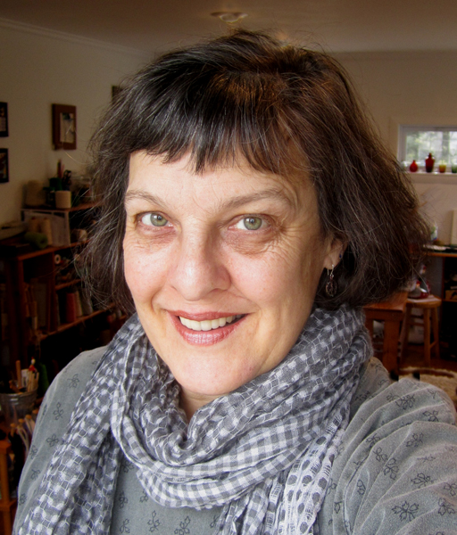**Janet Austin Tapestry**

East Greenwich, RI

www.austintapestry.blogspot.com

janetaustintapestry@gmail.com

**Instagram:** janetaustintapestry

**Artist Statement:**

My tapestries grow out of my drawings and paintings; sometimes they sit around for years before ripening into material for my tapestry designs. I make copies, then use a cardboard viewer to identify and cut out pieces that look like tapestries. My goal is to preserve the spontaneity of the quick sketch, as it is translated into a medium that is necessarily slow and methodical.

Chaos, and her children, Chaotic Fragments, came from a 27 year-old oil painting of my messy studio table. A fallen cone of yarn somehow morphed into a black hole in the universe. I had finally found Chaos. In the 9th Chaos tapestry, there appears to be a period of calm after the storm.

**Bio:**

Janet Austin studied fiber arts at Massachusetts College of Art (BFA 1978), and painting at the University of North Carolina at Greensboro (MFA 1981). After weaving and selling functional items (rugs, scarves, shawls, pillows etc) for 8 years, the weaving and painting merged into tapestry, her primary medium since 1983. Her work has been exhibited in national and international venues, including tapestry, fiber art and all media exhibitions.

Janet served 8 years on the board of directors of the American Tapestry Alliance (ATA), and 15 years as Coordinator of Tapestry Weavers in New England (TWiNE). She weaves, paints, draws, lectures, writes, and teaches in East Greenwich, RI.