By Janet Purcell | For The Times of Trenton
on November 23, 2016 at 7:00 AM, updated November 23, 2016 at 7:07 AM
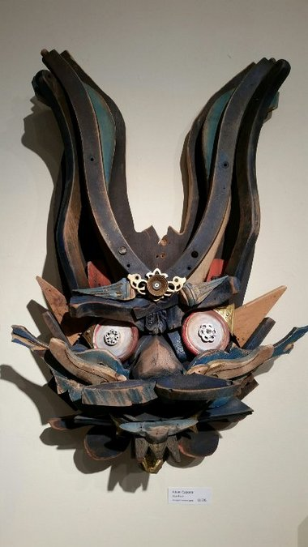"Blue Hare" by Adam Capone.Courtesy photo
For this, the 17th annual juried exhibition celebrating the woodworking tradition of Bucks County, jurors, custom Keith Sandberg and Roy Pedersen made their selections from more than 400 submitted works. On display are 85 works by 53 artists.
Juror Sandberg, of Doylestown, is a custom woodworker, design artist. Pedersen is an independent curator, collector and owner of Pedersen Gallery in Lambertville. Their collective experience has put together a show that stands out as particularly significant in the sixteen-year history. Kudos also go to Christine Ramirez for her direction in designing the layout and implementing placement of the works on display.
"We are thrilled that we have returning artists as well as new participants," says Carol Cruickshanks, New Hope Arts Executive Director. "There's a lot of variety in this show because we feature not only furniture but sculptural pieces, vessels and turned objects and many are unique affordable pieces."
Outstanding in the unique genre is Daniel Walter's "Cigar Box Ukulele" made of the wood box, mahogany, zebrawood and maple. It is not only unique in design but is playable. He is also exhibiting an "African Bass Guitar" constructed of hardwoods, Bocote and African mahogany. Among the unusual details further making this an even more distinctive work of art are the pairs of Zircornite African masks placed one pair at the nut at the top of the fret board and the other pair at the bottom.
Also exceptionally unique are Edward Murphy's three "Carnevalle Stools." The collection was recognized for exceptional craftsmanship in the Fine Furniture category. Constructed of multiply plywood which he then painted to bring out the contours of their bases, they also sport the feature of spin able rounded seats.
And unique in a fun way is Holly Smith's "Herr von Trapjaw," a beyond description work that hangs by chains on the stage. Made of multiple colorful parts it mimics a colorful child's swing at the bottom and a seat with long green legs that ride over a pink bar at the top. Intrigued? You have to see it to understand what I'm trying so unsuccessfully to describe.
Unique and imaginative are Adam Capone's "Blue Hare" and "Focus" made of salvaged furniture parts. Also Charles Adams' "Guardian Chair" and his "Self As Guardian #1." These are chairs with oversized anthropomorphic shapes that grab your imagination and tickle your sense of humor.
But then there are so many serious entries such as Kevin Scheimreif's "Maple Cookie Table and Chairs (2)" with powder coated aluminum frames. The chairs are pulled up to a table whose curvilinear sugar maple slab top shows nature's artistic veining design and a dramatic black steel inlay.
And there is no way you can miss Karl Frank Slocum's solid black walnut, ambrosia maple topped coffee table. Nor William Stowe's "Doza #1," a South American mahogany table with drawers underneath that was recognized for exceptional craftsmanship in the fine furniture category.
Turning now to vessels and turned objects, be sure to see Bernard Hohlfeld's Hollow Forms. His "Hollow Form #2," recognized for exceptional craftsmanship is an elegant object crafted from Wych elm burl and African blackwood with a glowingly warm cast acrylic resin. Displayed nearby is Michael Kehs' red elm burl vessel also recognized for exceptional craftsmanship. He is also exhibiting "Dragon Tea," a teapot crafted of ash, mahogany, maple burl and copper. Though box like, its curved spout, handle and top cap are clad in copper, thus accenting its pebbled jade green surface.
Jack Schiller's "Open Segmented Vase II" constructed of small segments of holly, Wenge, ebony and bloodwood is intricately designed and pieced, as is the colored wood inlay in Bryan Richardson's "Cherry Bowl" and the rim of Geoffrey Noden's walnut with dyed holly, Japanese pagoda tree "Walnut Platter."
Norine Kevolic's "Tree of Life" and Randy Leibowitz Dean's "Dream Changer" are more nature oriented. Kevolic's comprises bamboo, carved birch and poplar in a wall art piece where leaves rise from the surface on delicate stems with a life of their own. Dean, working with beech and pin Plywood and adding acrylics and ink has created a wall art work where a gleaming white full moon rises over curved and rounded dream-like earth shapes.
Although Andrew Shrift was recognized for his outstanding workmanship in his magnificent cherry "Sunflowers," a tall open work wall sculpture, be sure you also see his "Peacock" and his graceful "Dragonflies" that that flit across this work as it spans the wall above an open area. Done in cherry butternut, white oak, and maple on Amish Barn Wood, it is an innovative idea that is expertly crafted.
When you visit this exhibit I think you'll agree with Cruickshanks who says it is the best Works in Wood show yet. "Every year these shows get better and we certainly expect the bar will be raised even higher next year as well."
Yes, of course that's possible, but this one is going to be hard to beat.
IF YOU GO:
WHERE: New Hope Arts, 2nd Floor Gallery, 2 Stockton Ave., New Hope.
WHEN: Through December 18. Hours, noon to 5 p.m., Friday-Sunday and by appointment. Free and open to the public.
SPECIAL EVENT: Silent auction during exhibit. 500-year old reclaimed redwood plank from Humboldt County, CA. May be examined by appointment. Final bid accepted until 5 p.m., Friday December 16.
CONTACT: 215-862-9606.

