Fine Arts: Paintings By Sandy Hanna
Updated 4:07 AM; Posted 4:07 AM
By Janet Purcell
For The Times of Trenton
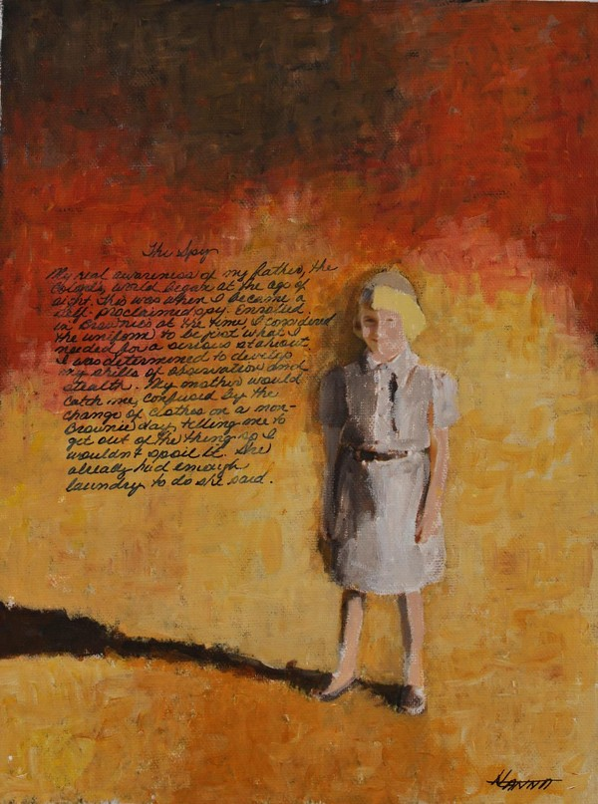"The Spy" by Sandy Hanna
Sandy Hanna readily admits she grew up as an Army BRAT, an acronym for Born, Raised And Transferred. On exhibit now at the New Hope Arts Center are 21 paintings with accompanying text panels telling the story the paintings illustrate. The paintings are based on family photographs taken in 1960-1962 when she was eight to ten years old and living in Saigon--or as the French called it, "Paris of the Orient." She describes that period of her life "I'm in an exotic land living a life of French decadence prior to the horrific experiences that would unfold for both the American and Vietnamese people."
One of four siblings, she tells with delight about her father, whom she refers to only as "The Colonel," gathering the family by the globe, spinning it and letting his finger track to where they would be living next. The old globe that played such a major role in Hanna's childhood is on exhibit, as is a traditional Vietnamese dress her (American) mother wore to a special military event, and a ceramic Vietnamese elephant that had stood outside the Hanna's villa. The large New Hope Arts gallery is festooned with colorful dragons and red paper lanterns used for New Year celebrations suspended from the ceiling. There's a large leaf hat of the Vietnamese people, and a papier-mache likeness of President Diem her family purchased from a vendor at Diem's birthday parade.
A good place to begin your walk with Hanna through her fascinating experience is her painting, "The Spy." It depicts her as an eight-year old wearing her Brownie uniform that she says she wore whenever she was "on stakeout" spying on the Colonel's activities which she says she began when she discovered his WWII photos of a concentration camp he had come across when with General Patton's Third Army. The painting portrays her standing as if stopped in mid stride in an environment with no detail other than her written words that appear on all the paintings.
You move from that painting to "Destination Saigon," a portrait of the three-tailed Constellation MATS plane that had transported the family to the heat of Saigon. She captures the strong light of the day well in the stark simplicity of the scene and the airplane having come to rest in its intense shadow.
"The French Villa" is a painting of the white-washed stucco home assigned to her family where she says "We became the French, living in their villas, speaking their language, using their sports clubs, and looking just like them." In this, she shows a lone figure standing in the empty road in front of the villa that is shaded by a heavy growth of palm trees.
In "Le Cere Sportif" we see young Hanna at the swim club--a club the Vietnamese did not join because of "Mr. Nhu, President Diem's brother, who had a contingent of spies who recorded anyone who fraternized with Americans."
The exhibit takes you from Hanna's family experiences to "The Coup," her painting depicting a military truck filled with soldiers carrying M1 rifles that was passing by when she says she and her siblings heard a firecracker go off and the soldiers began firing. "We found ourselves in the middle of a coup," she says in the text panel.
Another painting, "Girl Scouts and Mine Field," is displayed with barbed wire surrounding its black frame. In an attempt to not deprive the girls from American experiences, a Girl Scout troop was formed which Hanna refers to as "probably one of the most bizarre versions of American life ever superimposed on an Oriental landscape. ...What person in their right mind sends a Girl Scout troop to a cleared out mine field?"
In further paintings and exhibition materials, Hanna describes those coming of age years as a "life revolved around servants, learning French, afternoons at the Cercle Sportif swim club, movies at the underground theater, running a black market business with her thirteen-year-old brother selling baby powder and Hershey bars..." as well as spying on her father.
On display is a painting, "The Colonel," showing him astride a horse statue, smiling broadly with one arm waving his hat in the air. Hanna writes "He became Patton's procurement officer and was able to take advantage of his Texas horse trading skills."
In the text accompanying a nearby painting, she writes of how her father and his team were sent to disarm a bomb that had been dropped by an American WWII era fighter plane. The bomb had hit the end of the Presidential Palace but had not exploded. This painting, "The Palace Bombing" is a long view of the palace with flames climbing up the front of the regal white building.
In a poignant painting, "Long Life For 100 Years," portraying a bearded old man walking with a cane, Hanna tells about Tet, Nguyen Can, "the holiday that celebrates the lunar New Year... a time of great celebration in Saigon and throughout Vietnam, complete with fireworks and dancing street dragons. ...a time to welcome deceased ancestors back for a family reunion with their descendants."
"New Hope Arts is pleased to host this unique art exhibition that compliments the soon to be published book of Lambertville resident, Sandy Hanna, The Ignorance of Bliss, An American Kid in Saigon," says Carol Cruickshanks, Executive Director, New Hope Arts. "The 21 paintings, specially created by Sandy for this event, are images based on her family photographs depicting her life in Saigon as a ten-year-old military dependent from 1960-1962. The story is engaging and entertaining and a fitting exploration of a culture forgotten and clouded by the history of the Vietnam War. New Hope Arts is not just about visual art but literature, music--all the arts."
IF YOU GO:
WHAT: An American Kid in Saigon" Paintings by Sandy Hanna
WHERE: New Hope Arts Center, 2 Stockton Ave., 2nd Floor, New Hope, PA
WHEN: Through March 5. Hours, Noon to 5 p.m., Friday, Saturday, Sunday
CONTACT: (215) 862-9606. newhopearts.org
Follow NJ.com on Twitter @njdotcom. Find NJ.com on Facebook.
View Comments

