CAST IRON TOWN NAME SIGNS
HISTORY OF THE SIGNS
By Jack Graham

The old Town Name signs of Pennsylvania are made of cast iron. When new they were painted dark blue; the edge of the signs and the lettering were bright gold/yellow. They were mounted on a decorative fluted cast iron post that was also painted the same dark blue. These of course are the colors associated with Pennsylvania. Unlike modern town name signs which only give the name, these cast signs also gave the following information: distance to the next town, some bit of information about the derivation of the name, and the year in which the town was founded.

These signs were a project of, and were produced and installed by, the state Department of Highways, predecessor of today’s Department of Transportation. The program began in the 1920s. The Department of Highways Biennial Report for the 1926 to 1928 period states, viewed at the State Archives in Harrisburg, states: “The Department also makes a practice of marking the limits of boroughs with cast iron signs on which are a few facts as to the date the community was founded and the derivation of its name.“ No earlier reference to these signs was found. Highway Department reports through 1942 continue to make reference to these “historical” signs. After that no such references are found, so it is logical to conclude that the program was discontinued around that time. Thus the “newest” of these signs are well over 60 years old.

Pennsylvania has an extensive program of “Historical Markers”, also blue and gold in color, that give much information about persons, places, buildings, and events in Commonwealth history. These signs are a project of, and are produced, installed, and maintained by, the PA Historical and Musuem Commission (PHMC). A complete index to these markers is published from time to time. Perhaps because of their color, one could assume that the remaining Town Name signs were also put up by the PHMC, and thus that a good index to them is existent. Unfortunately this is not the case. Thus far at least, no records of them have been found in Highway Department files at the State Archives.

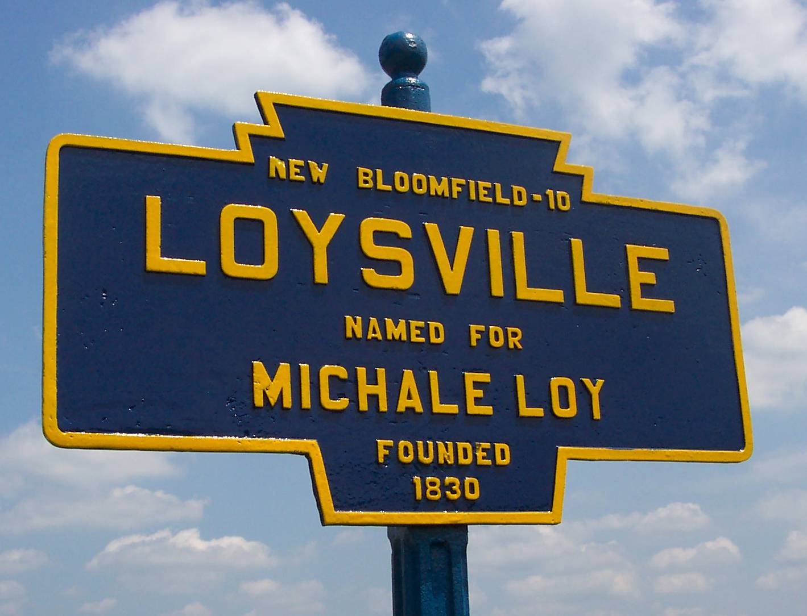
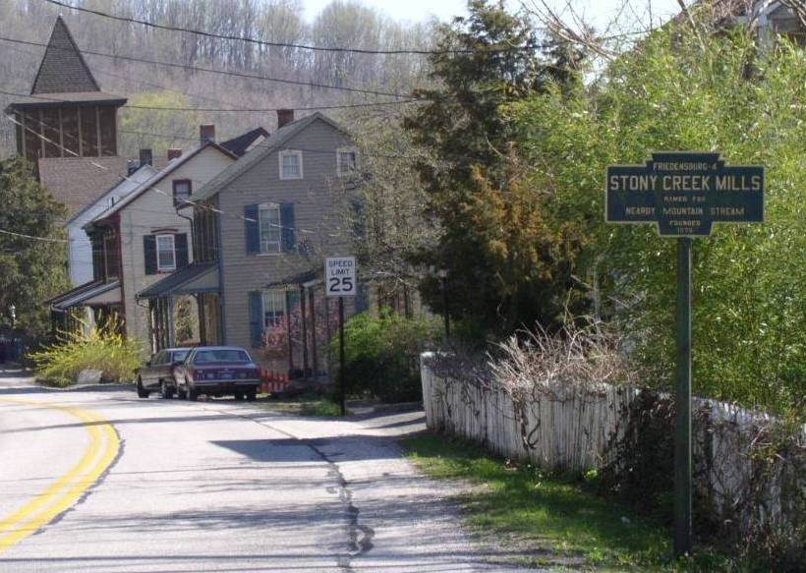
Many of the Town Name signs show the name of the manufacturer in small raised letters on the reverse side. Many of them show no such names, or the small lettering has become obliterated over time. The two companies that are known to have made these signs are: (1) Carlisle Foundry Carlisle PA; (2) Geiser Manufacturing Co. Waynesboro PA. Both firms are long out of business. Whether the unmarked signs were made by these same companies, or if there were other makers also is unknown.

At towns where the signs were installed, at least two were put up, one on each end of town along the major roadway. Usually but not always, this was a numbered “PA” route (PA 45 for example), or a numbered “U.S.” route (U.S. 322 for example). If a town was at the intersection of two such roadways, there were four signs installed, two on each road. All of the information on the several signs at one town was the same, except for the distance to the “next” town, which of course differed depending on which way the driver was going. The photos above show the two signs at Beaver Springs PA (Snyder County). Note that the top line differs on each as the “next” town is different depending on your direction of travel.

Some of the signs omit the top line distance to a “next” town, but this is the exception. A few omit the “Founded” date at the bottom, or say “Settled” instead. In a few instances it is evident that the top line letters were removed for some reason. This sometimes happened where new “limited access” highways cut off old roads, so that the old joke “you can’t get there from here”
came to pass.

Where the signs remain, the communities, or more likely some enterprising person in the community has stepped forward to repair or repaint the signs. Being of cast iron, they are very brittle and subject to breakage. A surprising number show signs of being repaired either poorly or well. Far too many however, stand neglected at the side of the road. The LOYSVILLE signs, one of which is shown above, are examples of some recently cared for. But the AIRVILLE sign at left is far more typical of present conditions.

A few others in great need of care. (Additional photos sent separately.)

