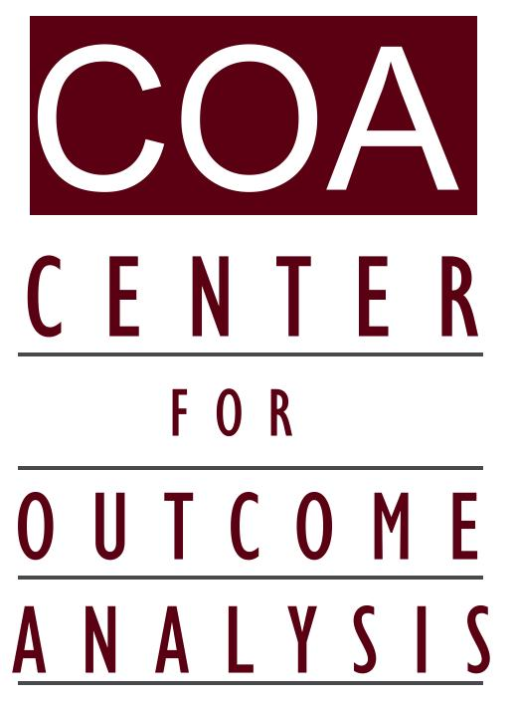
426-B Darby Road
Havertown, PA 19083-4626
610.246.5961 – jconroycoa@gmail.com – www.eoutcome.org

COA White Paper:
On the Need for Outcome Data in the Move to End 14(c) Models of Day Supports
July, 2015

As a personal observation by a scientist working in the field for 45 years, I have been troubled over the past decade by the lack of solid longitudinal quality of life & outcomes science on the folks with intellectual & developmental disabilities who have left sheltered workshops and 14(c) sub-minimum wage situations. Now that DOJ is using the Supreme Court’s 1999 Olmstead to question the large scale segregation in some of America's day programs – primarily workshops – the controversy is heating up.

There is currently a “case study” investigation circulating in Washington DC, out of GWU, reputedly funded by The Chimes and supported via ANCOR. It suggests that the outcomes of closing 14(c) settings in Maine has been very negative. But it is based on interviews with representatives of 7 provider agencies, and just 5 people who experienced the transition. It's making waves nonetheless.

In essence, my sense is that several states ended all 14(c) programs (e.g. Vermont first and then New Hampshire), but failed to track and document what people are doing now, what they are earning, and whether their lives are better (in what ways, how much, and at what cost).

This failure has opened up an opportunity for workshop proponents to promulgate “quick and dirty” studies like the GW one. Such studies will gain legislative attention quickly.

I understand that, just as in the 1970s and 1980s with deinstitutionalization, many parents are extremely concerned. They have no certainty that “what comes next” will be as good or better than the workshop situations. The workshops and day programs, we must remember, are the product of decades of strenuous advocacy and “do it yourself” struggles by the parents and friends in the Arc movement over the past 60 years. What we have now was hard to get – and parents today do not have good evidence to be confident that their sons and daughters will not be left sitting at home for many more hours per week.

Public policy is at a crossroads - and should not be guided by poor or incomplete studies about the quality of the lives of the people affected. (By this phrase I include integration, earnings, engagement, and self-esteem.)
I have begun work on a research agenda that will produce the evidence needed. Some of it can be done quickly, immediately, and will yield useful information, and some will take a few years to complete. But the need is urgent, and the research community should begin immediately.

COA Version 3
6/30/2015
Multi-State Multi-Phase Investigation of Alternatives to Sheltered Workshops:
Individual and Agency Outcomes

Problem statement

America is in the midst of questioning the values and outcomes associated with a very old model of support for citizens with intellectual & developmental disabilities: sheltered workshops and their use of sub-minimum wages. As early as possible, we must have clear scientific evidence that people will be better off, on the average, if they leave sheltered workshops. The scientific evidence now available is not definitive. Unequivocal evidence is urgently needed.

Primary goal

Answer this question for valid samples of agencies and individuals: Are people better off in alternatives to sheltered workshops? The subsidiary questions are: In what way(s), how much, and at what public costs? We will also seek to answer questions about agency survival, stability, quality, and fiscal viability.

Research design considerations

The best design to determine whether “people are better off or not” after leaving the workshop model would be longitudinal, with pre and post measures and random assignment to one of two groups: leave workshop or remain. This must be done, but it will take a long time.

In the meantime, the scientific community concerned with this urgent policy issue should begin with a multi-phase research initiative. An outline is given below. The first two phases are designed to be very useful, but very fast. At the initial stages we sacrifice sample sizes in order to obtain unbiased data quickly. Then we can move on to larger, more representative samples.

Phase 1: Web Survey of a Purposeful Multi-state Sample of Approximately 30 Agencies and Executives that have Ended Reliance on Sheltered and Sub-Minimum Wage Models – Complete by September 30.
- An opinion survey of leaders who have “done it.” Fast, simple, and informative, but not nationally representative.
- Questions such as “Why did your agency do it?” and “Rate what you think is the overall quality of life change for folks affected.”
- This Phase also requests assistance to gain access to small random samples of individuals and families who went through the transition – even as long as 10 years ago. We will need the agencies to contact random samples of (first draft 30) people each, to ask their permission for us to contact them and interview them.
- This could yield as many as 300, but more likely 100, completed interviews about changes in folks’ lives since ending workshop participation.
- But because the initial sample of agencies/executive was purposeful, not random, we cannot fully claim national generizability.

Phase 2: Individual Personal Interviews with People Who Transitioned – Complete by December 31.
- Based on our ability to contact people who lived the transition in several states, we apply simple quick nationally tested interview instruments to conduct face to face interviews. These interviews are all about the questions “Are you better off, in what way(s), and how much?”
- We could wind up with between 100 and 300 completed interviews, more than anyone has ever done thus far on this topic.
- Our samples within each agency will be random, without bias.
- However, the entire sampling approach of states and agencies is not random. This does not mean the information is without value – it means we cannot be as confident as we would like that our findings here are true in all the other states and agencies that were not in our sample.

Phase 3: National Web Survey Study of American Agencies that Have Accomplished, or are Considering, Transition away from Sheltered Workshops – Complete by August 2016.
Using modern websurvey technology, we can identify many hundreds of agencies that have accomplished workshop closure. (Or are considering it.) For those that have completed transition, we need to ask them simple straightforward questions about how they now view that change.
Preliminary Examples:
In your opinion,
- What impact has the change had on the financial viability of your agency? (Five point scale.)
- What impact has the change had on the quality of work life of DSPs?
- What impact has the change had on management?
- What impact has the change had on people’s qualities of life – what proportions are now better off, about the same, or worse off ? (May include several questions.)
- What impact has the change had on peoples’ incomes? (Proportion higher, same, lower.)
- What impact has the change had on people’s integration – contact with non-handicapped citizens?
- What impact has the change had on people’s real connections, relationships, friendships, family cohesion? (Complex question to be broken out into several.)
- What impact has the change
- Describe in words your perception of the pluses and minuses of the change.

We will also include at this Phase agencies that are considering transition, for a simple and shorter set of questions, because they can become candidates to participate in the Phase 5 Pre and Post investigation.)

We would seek the collaboration of ANCOR, APSE, and any other entities in possession of lists of day program and employment supports to obtain emailing lists.

This national websurvey would mirror Phases 1 and 2, in that it will ask assistance to gain access to individuals who have experienced the transition.

Phase 4: Individual (and Family) Outcomes of Transition from the Phase 3 National Sample – Complete by December 2016.
Much larger numbers, and greater representativeness, than the Phase 2 investigation.

Phase 5: Longitudinal Study of Workshop Transition Outcomes – Pre and Post. Complete by 2018.
This is the one that will take years. We should start now, with all (or a sample of) the agencies we find in Phase 3 that are planning to end sheltered models.

This social change process is in many ways parallel to the prior shift away from large institutions as places for people to live. There was significant fear of the change, and also a series of small studies that purported to show that the change would hurt people and/or wreck the financial foundations of the system in place (such as McCann, 1984). The American answer to this was the Pennhurst Longitudinal Study, which provided well designed and highly reliable scientific evidence that “people were better off” after leaving institutions. The PLS was replicated in more than a dozen states even before it was finished (Conroy & Bradley, 1985).
The states that have ended all sheltered and sub-minimum wage models, such as Vermont, would have been ideal places to answer these crucial questions – more than a decade ago. Each person’s qualities of work life and other aspects of life, and social costs, could have been measured when they were still in workshops. Then their status could have been measured after workshop closure. This would have constituted a pre and post or longitudinal study. If it had been done, we would have little or no doubt today about whether this change was good social policy, justified by enhances well-being of the people supported. We regard it as very unfortunate that this was never done.

