New Leash on Life USA
Longitudinal Study of Outcomes and Costs

The First Group: Qualitative Analysis

Outcomes Report #1 in a Series

Submitted By:

Center for Outcome Analysis
Havertown, PA
www.eoutcome.org

January, 2012

Foreword

This report is the first in a series evaluating the costs and outcomes of the New Leash on Life USA programs in Pennsylvania.

The New Leash program is described on the website at http://newleashonlife-usa.org/about-us.php:

New Leash on Life USA is a new generation prison dog-training program that saves the lives of shelter dogs by training and socializing them to enhance their adoptability while helping inmates learn to train and care for dogs.

With New Leash on Life USA, dogs live in the cells with their inmate trainers 24/7, making New Leash dogs highly desirable for adoption and ensuring the long-term success for both humans and dogs.

New Leash on Life USA provides:
- Weekly sessions with professional trainers, animal behaviorists and veterinary technicians.
- Job readiness and life skills courses to improve successful reentry and employability for inmates upon parole.
- Scholarships for paroled inmates for additional training and education in the animal care field.

The Center for Outcome Analysis is a nonprofit firm devoted to rigorous scientific analysis of social programs. Founded in 1985, it has conducted some of the largest longitudinal studies in the fields of disability, special education, and health care financing. COA is founded on the principle that public policy should be guided by the measurable individual quality of life outcomes of public programs, always including consideration of both costs and benefits of every program.

This series of reports begins with a qualitative analysis of the first group of four dogs to be rescued via New Leash, working with six inmates of the Curran-Fromhold Correctional Facility – Philadelphia’s primary jail. This first report is intended as a plain-English, popular media explanation of how the first cycle worked. The second will be a qualitative article on the same subject, but written in professional form and style for publication in a professional journal. The series will then explore the quantitative study of the men in the second cycle, including pre and post measures of attitudes and hope. Later in the series, we will follow up on the participants to determine recidivism, cost savings, and changes in incidents and violence within the cell block. Correctional Officers and Philadelphia Prison System officials are an important part of these studies.

Animal programs in prisons are not new – but according to every author who has described them, the need for solid evaluation and cost/benefit analysis is great. This Philadelphia program offers the best opportunity yet for good science – the city and the nation need to know how much, and what kinds, of benefits to expect – and at what cost, or with what cost savings. That is the overall purpose of this Outcome Analysis series.

Contents

Introduction 1
New Leash on Life USA: Origins 2
The Founder 2
The Reality Check 6
The Trainer 14
The Teacher 18
The Corrections Officers 19
Animal Programs in Prisons 19
Re-Entry – We Don’t Make It Easy 23
A Graphic Example of Re-Entry Difficulty: Prisoners with Mental Illness. 24
The First Graduation 26
Lucas – “Least Likely to Succeed” 28

Introduction

There’s a dog and a man in mortal danger. You can only save one. Which one?

But what if you had a chance to do both?

That’s the central concept of a new project in Philadelphia – New Leash On Life USA has begun to save “problem dogs” from being put down – by thoroughly retraining them – and getting them good homes. And who does the training? Men in the main Philadelphia jail.

There have been formal animal programs in jails for at least 40 years, and informal ones probably throughout human history. But until 2011, there were none in Philadelphia. Now there is one – and it is well organized. There is an intensive scientific study under way to measure the costs and outcomes, too.

New Leash on Life USA: Origins

This is the story of how New Leash on Life got started, how it worked in the first incarnation, and its prospects.

The first group began with eight men and four dogs. It ended with six men and four dogs. As the program is described, we will focus on the story of one of the participants, a young man named Lucas, because his story illustrates some of the most important facets of relationship with a dog, of prison life, of rehabilitation efforts, and of a man trying to stay out once he gets out.

We begin by quoting one of the participants – the briefest, but perhaps the most informative, from our dozens of hours of interviews:

“…and there hasn’t been any crashing heads in like over a month.”

The beginning of New Leash on Life USA can be traced to its founder and a small core of experts devoted to second chances – both for dogs and for men.

The Founder

Picture a woman of substance, who has run her own marketing business, good looking, well dressed, successful – arms deep in dog chow at the Philadelphia animal shelter, then walking the dogs in the rain and the mud in the winter. That would be Marian V. Marchese in 2008.

I decided that for Christmas 2007 I would volunteer in an animal shelter for the day, just for Christmas day because all of our family was committed to other things on Christmas so we were going to do our Christmas on the twenty-sixth. That meant I had the day, with no one coming over so I thought I would go to the animal shelter. I called Morris animal refuge, I called Main Line Rescue, I called a couple of other shelters and either they didn’t call me back or they called me back and said that they couldn’t use untrained volunteers on a holiday, but I should just either bring supplies or send a check but in a nicer way.

So, I called someone I knew through the Forum of Executive Women group that I belong to, had belonged to for years. She had a high position in the City. So she called the main City animal shelter and she said “I’m sending somebody up, and you’ll use her for Christmas.” So she called me back and told me to go up there, and she said it’s in Feltonville.

I said I didn’t know where that was. My husband said, “Lock everything in your car.” So I did, I locked my keys, I locked my cell phone, I locked my wallet, my drivers license, everything in the car.. I drove up and it was a miserable Christmas day, it was grey and sad, there was no one at the shelter.

I walked in and the smell was overwhelming to me, and the noise was overwhelming, I mean the barking was so loud you could not hear and I couldn’t hear myself speak. And there were very few volunteers there and a skeleton staff, and I said “Oh, I’m a friend of so-and-so, and she sent me up here” but they didn’t seem at all impressed.

They said I could go and help in the surgery room, and I said I didn’t think that was a very good idea, was there something else I could do.

So they said I could go outside with a pit bull puppy and I had not seen any pit bulls. This shelter’s mostly pit bull mixes. So we went out in the yard to play ball. Now my dog Charlie doesn’t play ball, he doesn’t do much of anything. So there was a ball there, and this puppy was running around, and I saw the ball and I went for it and the puppy went for it, and I got it first and the puppy then grabbed my hand and bit through the flesh and pinned my hand to the ball, and the blood is gushing out. And there’s no one else in the back yard. I don’t remember it hurting. I was so shocked and I couldn’t get the puppy off the ball. And literally, the dog is so little that he’s hanging on my hand with his teeth and swinging and the blood is gushing all over the dog, and all over my hand.

And then another volunteer happened to come out and she put her dog away, came over, pried the puppy’s jaws apart. Then the blood is even gushing more. So the staff now had a stupid volunteer and massive amounts of paper work. Everybody had to stop what they were doing. We had to fill out all kinds of insurance papers for the city, and then they put me in an animal control truck and one of the staff drove me to a hospital.

He dropped me at a hospital I didn’t recognize. Just left me there. I had to go through a metal detector, and sat in the emergency room, and then they came and got me and I didn’t have any ID or money, everything was locked in my car. I didn’t have anything. So, I said I was from the shelter and a dog bit me, and they wanted to know what kind of dog, and I said it was a poodle. And they said that was very unusual for a poodle to bite.

And so there I was, in a gritty city hospital ER on Christmas day, and that means that half the people in the emergency room are drunk and handcuffed to their bed! And the other half is knife wounds and gun shots. I got stitched up and called home. I told my husband what happened, and he said “Well do you want me to come get you?” And I said “No, I’ll just call the shelter and tell them to come pick me up, and take me back, and then I’ll leave.” So they had sterilized my hand, stitched it, X-rayed it then they put this giant bandage on because they knew I was going back to the shelter. I stood outside the emergency room door and waited for the animal control people to come pick me up.

They picked me up in a truck and took me back. So now it’s dark. The front of the building was closed, but the back of the building was open, so they said I had to go in the back and talk to the supervisor.

I went in the back, my hand is throbbing, and they had just finished taking the animals they euthanized that day, wrapped up in plastic garbage bags out of the freezer, put them in a bin on wheels. Then they wheel that to a truck and dispose of them. I walked in just as they started moving the bin. So I am walking behind all the dead dogs and cats from the day. Piled high with the smell of death coming from it.

All of this, you might say, had a bit of an impact on me.

Anyway I went in and I thought they were going to say please don’t come back. I don’t know if they thought I was going to sue them but I certainly wasn’t. They asked if I’d come back and then I did, I came back every day with that bandage on, and a trash bag wrapped around it, and became a crazy volunteer for a couple months.

Volunteering at the shelter, Marian met some people who cared every bit as much as she did about saving dogs from being put down. She learned a great deal about the horrendous numbers – the abandonments, the pickups, the lack of caring about the issue among most of us in the “regular world.”

-----------------------

The Philadelphia Animal Care & Control Team brings in about 9,000 dogs per year in recent times. About 3,600 of them will be put down, or euthanized, right there – the unlucky dogs for whom health care is not enough, or training is just not sufficient for safety, or for whom new owners just can’t be found.

Throughout most of American history, animal caring efforts have been stunningly under-funded. The founder of the American Society for the Prevention of Cruelty to Animals (ASPCA) movement. Henry Bergh, began his work in 1866 in New York, aimed primarily at horses.

Henry Bergh fought against the inhumane treatment of animals at the “pound” in New York City. In fact there was a cartoon depicting him as the only mourner following the poundmaster to the river to drown the impounded dogs. He was, however, adamant that the ASPCA should not take over animal control for New York City. He believed that the city would never provide enough funding to do the job well…a state of affairs that is common still today across the country.

Though situations have improved at some times, and in some places, there is a seemingly unending need for care, retraining, foster care, and adoption. Pennsylvania has been among the leading states in this area, lead by the Women’s Branch of the Pennsylvania SPCA later to become the Women’s Humane Society.

And there is plenty of blame to go around, perhaps led by the failure of too many owners to prevent reproduction via spaying and neutering.

Marian, following her trial by fire, naturally wanted to do something, to take action. Following a cart of dead dogs was not something she ever wanted to experience again.

Because so many dogs were being put down, I wanted to save more dogs. But I didn’t know how. And then I saw a program on Animal Planet called “Cell Dogs” about prison dog programs throughout the country. I knew that’s what I wanted to do.

So I looked for a program in Philadelphia and there was no program. So I decided to start one.

Later, when Marian continued to volunteer at the shelter, she was placed under a manager named Mr. Rosa.

The Reality Check

Mr. Rob Rosa is a senior manager at the Animal Care & Control Unit. Working with Marian was ….. “different” …… for both of them. According to Rob, when Marian first got the idea, the inspiration, to help save dogs through a prison program, she talked about it to anybody and everybody who would listen. As Rob tells it,

I remember the day. It was a holiday. I very rarely speak about my past at work, but when she was organizing New Leash on Life, she asked someone at the facility about how she could go about doing it. And that person was a close confidant of mine. She said “Why don't you ask Rob and he can tell you a lot about programs like that.” And she thought “Why Rob?” because she had no clue. So she came over and she asked me about it. And I said yes I can tell you about it. Actually, I can give you a lot of good points about it. First I said I want to show you something so that you know that what I'm telling you is not made up. So I took her over to the computer and I brought up my old newspaper clipping. And I let her read it.

The article he brought up for Marian was:

A New Lease On Life
09/06/2005
By: JEFF ERTZ , Staff Writer

COCHRANVILLE ― The 12 years that Norberto “Bert” Rosa was incarcerated in Graterford state prison had stripped him of the personal responsibilities the outside world expected him to dutifully pick up upon his April 18 release.
But it was Rosa’s participation in the puppy prison training program through Canine Partners For Life that offered him an opportunity few inmates receive.

By pure coincidence, if you believe in that sort of thing, Rob had been doing time in Graterford penitentiary in 2004 when he was offered a chance to work outside in an animal care program.

Marian tells the same story from her own point of view:

And Rob was the shelter manager. I always made sure that I did everything Rob said. And when he had a baby I got him a baby gift because I wanted him to know how much I respected him, and that I was happy that I was a volunteer who was allowed to do a lot of extra things. I have my own cart there, which is unheard of.

So I went back, and I said, “Rob, do you know what I’m doing at New Leash?” And he said, “Yeah.” I said, “Well if you know anybody, this is what I’m doing, I’m going to start in a couple of weeks, if you know anybody who could help me in any way, let me know.” And he said, “Okay.”

And I went away, and twenty minutes later he called me back in his office and pulled up this article about this guy named Norberto, Norberto Rosa, and I thought, well Rosa must be a pretty common name. And the article is all about all the work with animals that he did at Graterford Prison.

And I said, “Well I need to talk to this guy.”

And Rob said, “I’m that guy, I’m Norberto.” Norberto was Rob.

So he went with me to the meeting for private funding, and he’s the one who clinched the money. I had this fabulous PowerPoint, and they just talked to him. And he was perfect. He said “I was told at age thirteen I’d be a career criminal. I was a bad guy, I did bad things, I was never going to make anything of myself. And I got into this dog program at Graterford, I got paroled, I got hired by the dog program, went back to the shelter, and now I have a family, forty people report to me, I order everything for the shelter.”

So he’s the end result. And he didn’t have any of the wrap-around services; he didn’t have any of the extra stuff. So, what an inspiring story.

One might ask, “How could such a perfect parallel be coincidence?” We each find our own answers to that one.

One thing is certain: Mr. Rosa’s life has come a very long way. Seven years ago, he was doing time in Graterford Penitentiary. He tells his story in amazingly quiet and humble ways, making the impact all the greater. One wonders whether all true heroes are modest. Rob would deny heroism, but he does not deny that he is mighty happy to have escaped the life cycle of imprisonment, release, re-arrest, and so on – that might have been his lot in life.

When he was paroled in 2005, he had never even seen an ATM. But he had learned how to train dogs – really well. He was the best in the program.

While in prison, I started to want to change. I put in to join a program to work with animals. I was taking care of 38 cows, and I was feeding and caring for rescue horses. There was a dog program, a volunteer program, you didn't get paid for it or anything, to raise puppies who would later be trained as service dogs. I was very much interested in that, because I've always loved dogs.

I joined the program.

And I became a volunteer handler for the program. We trained the dogs in their basic obedience. I started to do very well with my dogs. In just a short time, they had their basic obedience, and I started teaching them skills, which is something that they usually learned on their second step, after they left our program. Here they were actually leaving the prison with some skills. I was teaching them to turn on radios. I was teaching them how to pick things up off the floor. I was teaching them how to find hats. I would take my hat off and put it in one drawer of the desk and asked the dog to go retrieve it. He would find it for me. I was teaching them to open doors and such.

Rob was so good at working with dogs, in fact, that the founder of that program offered him work when he was paroled. As Rob says,

So the director, who was a lady that I looked up to, who was my mentor, asked me if I would like to work with her. When I made parole and I accepted, and this was very helpful in my transition from prison to society.

People who know anything about prisons and parole know that trends over the past 40 years have made it crushingly difficult to “make it” back into “the world” after release. More about that later.

Through the reality of Mr. Rosa’s life, Marian saw that such a program really could make a difference. Without doubt, her alliance with Rob helped in every way, at every stage, to bring New Leash into being.

Rob himself is a living demonstration of what we should want as the outcome of imprisonment: a man who came out a better man than the one who went in.

-----------------

But that is not our recent American history. Not at all. Since the Nixon “War on Crime” years, the United States has expanded imprisonment beyond anything seen in human history – or in any nation, modern or not.

One of the primary reasons to consider canine programs in America’s jails and prisons is that we have overcrowded them to the point of cruel and unusual punishment. California’s entire state system of prisons has been placed under court jurisdiction because of overcrowding and failure to deliver even constitutionally minimal health and safety protections. As a nation, here is what we have done over the course of a century:

Incarceration Rates, 1925 to 2011
Source: Multiple – compiled and graphed by the Center for Outcome Analysis

The graph shows steady rates of imprisonment from 1925 to about 1973. (The graph can be taken backwards, too, all the way to the days of the founding fathers, and rates were steady the whole time.)

Then something changed.

Sociologists and criminologists may debate the causes of this rise – it seems pretty obvious to most that the phrases “Tough on Crime” and “War on Drugs” have something to do with it – but theories, aside, the fact is that “The United States has the highest documented incarceration rate in the world.”

And, since the financial crash of the past decade, liberals and conservatives and libertarians alike have all finally realized that “We cannot afford this.” Again, putting aside politics and ideology entirely, it is simply necessary that we stop expanding our jails and prison populations – and start reducing them.

One of the best ways to do this, of course, is to prevent men from ever coming back, once released. Returning to prison after being released is called by the scientists “recidivism.” One of the best ways to prevent recidivism is to make sure a man or woman has something productive to do upon release – a way to make a life and a living.

But that has not been our way over the past four decades. America largely abandoned rehabilitation in favor of punishment. “Three strikes” and mandatory sentencing typify this powerful trend. In the middle of the last century, a common correctional axiom was “No one should leave prison unable to read.”

That spirit vanished in America, to our own national detriment.

Here in Philadelphia, though, enlightened leadership has begun to shine a light on the problem. City jail population has decreased nearly 30% in just 3 years. Programs designed to rehabilitate and give a real chance at life on the outside have expanded – in spite of a powerful need for austerity. Philadelphia’s Mayor Nutter, Deputy Mayor for Public Safety Gillison, and Commissioner of the Philadelphia Prison System Giorla, and their staff and allies, have embarked on an extremely positive and necessary initiative to reduce incarceration, provide better training and rehabilitation, and prevent returns.

Over time, these public policy actions will make a great difference – and New Leash on Life USA is a program that fits perfectly into the new way of thinking about corrections.

-------------------------

Once set on her course, Marian Marchese employed her marketing and networking skills to the utmost – searching for political and financial support. Once the Commissioner of the Philadelphia Prison System, Louis Giorla, signed on with a letter of support in November 2009, doors began to “slam open.” This short description, of course, leaves out all the hard work and months of calls and meetings.

Most certainly, though, without approval and support “from the top,” New Leash didn’t even have a glimmer of hope. It took some firm words, too, from “on high” to get some of the Corrections Officers to step back and allow the training program to develop and thrive.

------------------

Jump forward to the first real day of New Leash on Life in the Philadelphia jail. Eight men are gathered into a small room, a library, in one part of the facility. There is room for five people, but seventeen are in the room. Marian, two Correctional Officers, the two trainers, the eight men, one photographer, and three scientific investigators, are present for this first session.

Introductions are made and the New Leash program is explained. It is evident that this is the first full explanation that has been given to some of the inmates. The group plunges forward into PowerPoint projections on the cluttered wall of the library, led by Laura Muller, who has assembled her most down to earth material for this unusual group of trainees.

The New Leash program is supplemented by Life Skills training, offered on other days, and other programs presented by other agencies. Every effort is being made to invest in these men, and make sure that they won’t return to this prison.

The first eight men in the New Leash work:

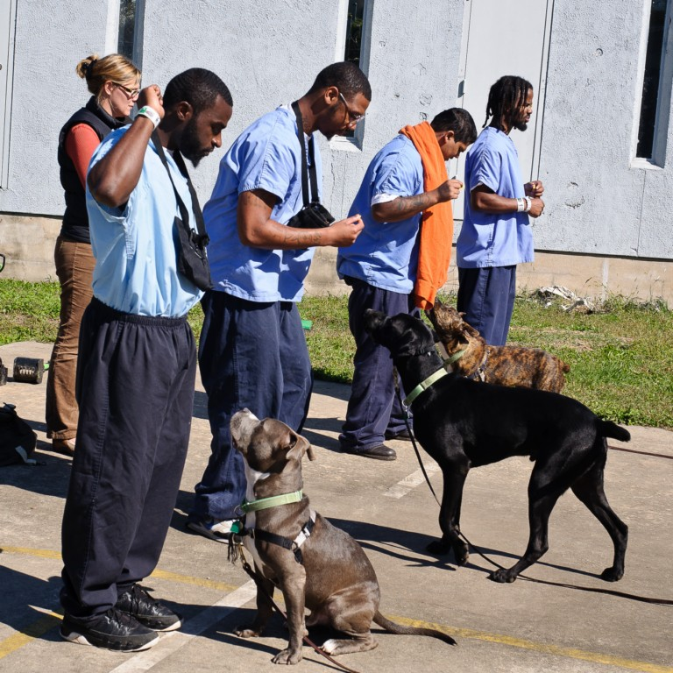
Four of the Participants, Three of the Rescued Dogs, and Trainer Nicole Larocco

Some of their stories are told in The Trainer’s review of the pairings of dogs with participants.

-------------------

The Trainer

One of the people Marian met while volunteering at the shelter was Nicole Larocco, former head of behavior training for the Pennsylvania SPCA and now a highly sought-after consultant who helps people solve all kinds of problems with their pets.

The way Nicole tells her story of involvement, the four dogs and the six men are really one story. Nicole’s training methods are based firmly on a century of behavioral science – and humanitarian impulse – and all training is based on reward, never punishment. Positive approaches are the absolute rule with Nicole.

Nicole tells a story about one of the first participants, Robert, and the dog assigned to him.

It was the first day, and it was with Robert, and I had my dog Ulie. And Robert said “I've had dogs for years.” And I said “Oh, so you know how to train them.” And he said “I do, I know it all.”

“Okay, great,” I said, “make my dog sit.” And he grabs her collar, he screams “Sit,” and he cranks down on her bum. I mean he pushed down really really hard. And my dog has been trained with 100% positive reinforcement techniques. So when she felt him push down on her butt she didn't know what to do so she stood up and looked at him. And he couldn't make her sit and he was yelling at her and he was pushing on her, and he still couldn't make her sit. So I walked over and I said “Ulie, sit.” And she sat. And he said “Well that's not how I train,” and I said “It will be. You wait. This is how we train and we are not training dogs the way that you are used to training them.”

It was at that moment that I knew which dog Robert was going to get. When I met Johnny Cash, that black Labrador. He was that kind of dog that you could yell at till you are blue in the face and you weren't going to break him. But he was also not going to do things because you forced him. So we gave Robert Johnny Cash. That was the dog for Robert, because Robert thought he knew everything. Robert didn't have a clue. So the first couple of weeks he was really cranking on that dog. So I said “You can't do that, you really can't do it that way. It just won’t work.”

And it wasn't until he started to really get into the positive reinforcement thing, and teaching Cash to do what he was supposed to do for treats, or for praise, or for love, that he really started to have results with that dog.

It’s funny because that dog knew, the second Robert would raise his voice, or the second Robert would get upset, or the second Robert would tense up, that dog would completely shut off, and you couldn’t get him to do a thing. And the second Robert asked him nicely, the dog would work beautifully.

And it was so interesting to watch because Johnny Cash shut down a lot during the first 10 week program. Because Robert was really hot – he was a hothead. So every time he would get upset, the dog would look at him, the dog wouldn't talk to him, the dog would walk away from him, the dog would not pay attention, and the second he brought it down – the dog would snap back and pop to attention and go with it. So that was Robert’s dog, Johnny Cash, the big black Lab, and he was really kind of a perfect fit – for him, for Robert.

At the other end of the spectrum was Dennis, who was a gentler and more cheerful young man.

I think about Mike Tyson being a perfect fit too. Not for Robert, though. Giving a dog like Tyson to somebody like Robert who was so hotheaded, he would've absolutely 100% broken that dog. I mean it would have been over and he would've really ruined that dog. Because Tyson is a dog who could not handle a lot of punishment. Tyson was the kind of dog that if you did something once - if you told him to walk an inch he would've walked a mile just because he wanted your attention and your approval.

And we gave Mike Tyson to Dennis. Dennis is really kind of a cool guy. I think Dennis has a pretty low self-esteem. He was the kind of guy who was always looking for approval himself. Always raising his hand in class and wanting us to tell him that he was doing a good job. They were like two peas in a pod and it was pretty cool to see how they came along together.

Dennis, with his little dog Tyson, he would beam around the dog. No matter what he said, as soon as that dog would come out and show off some tricks, he would just beam. So I think that, if nothing else, it was a social connection. Dennis had this … confidence when he was talking about his dog. But Dennis talking about other things kind of mellowed out and drew back and became very blank. But Dennis talking about his dog or showing new people how his dog did tricks, I think the dog just enabled him and a very, very good way.

Dennis was paroled along with the rest of the graduating class, and accepted a 30 day internship in dog training with Nicole as well as with the Delaware County SPCA. It was inordinately difficult for him to take public transportation, without his own money, to get to the shelter every day. He did it, though.

And the dog is interesting because Dennis said to me at one point, after he got out of prison and he was working with me, Dennis said you know everybody just lets you down at some point – except for the dogs. They don't let you down.

Something Dennis hadn’t experienced before seems to have emerged during his time with New Leash. It had something to do with “unconditional love,” according to Nicole.

That may not be true for me, but I was raised in a good home and it's different. But I think that dog really enabled him and I think that dog was somebody he could really trust.

Dennis's mother left him early, and his father is dead, and he had a couple of brothers and sisters who are dead. So of course he wants approval and unconditional love, he's never had it. I mean if you would see him parade around with that dog showing every random person to walk through the prison about how the dog did tricks, his pride was so obvious. And he wanted approval. For the dog, but I think for himself at the same time.

He would come to me when we're teaching, and he would say well Tyson is the best isn’t he? And I would say yes Dennis he is the best, and you are working the hardest, and it was all a part of constantly seeking approval. What a change from the beginning. But the way that dog looked at him and the way he looked at that dog, you know that was his approval. Dennis needed that dog to just keep his head on straight. It was a different kind of reinforcement. With Dennis that dog was pure positive reinforcement. Dennis didn't need negative reinforcement, he didn't need any punishment, which is good – because there wasn't going to be any from us. And that dog that he had, Tyson, was so right for him.

Nicole also describes one of the men who was recruited for the first New Leash group – but who clearly was not told what it was all about.

Will, he hated dogs. It was funny, too. I don't know how he got into the program, actually. That kid did not like dogs. He didn't want to look at dogs, he didn't want to touch dogs, he wanted out of the program, and when he heard he was getting a Labrador, he was out. He knew that Labradors were big, and that's all he knew. He didn't want one. But at the end, man, he was really attached to that dog, and was teaching him things, and now he's just studying to be a dog trainer, and he's not afraid. It's really pretty cool and was amazing to see.

For Nicole, this first New Leash experience in the prison was by no means easy. In fact, she says,

Being with these guys was extremely challenging for me. At first I don't think they trusted me. They looked at me like you're not really part of them. You know, I don't think that first group of guys knew what they were signing up for at all. And I thought I knew what I was signing up for. But – it’s really a lot different once you're actually in there doing it. So it's been a real experience for me learning to deal with these guys, and how to really get through to them. Because there's a certain amount of you that can't take any crap at all. If they dish out crap, which they always do, I can't take it from them, I’ve got to kind of throw it back at them. But at the same time I've got to remember that they’re people, and I can't throw too much back at them, or be too sarcastic with them, or anything like that. Because then they shut down too.

Nicole talked about this as the art of “setting limits without being negative.” She admitted that it was difficult. And yet, with all her years of experience, avoiding punishment, anger, and reaction from emotions, seems to be second nature. Still, this was a new kind of “client” for Nicole:

I don’t have to set limits with my clients. Clients are paying me 100 dollars an hour to come to their homes and train their dog not to bite people. I don't have to set limits with them. Because they want my help, they’re seeking it out, they want my advice, they want my feedback.

These guys not necessarily. They don't think that I have anything to say to them that can change their life, until they get to know me. You know, I hope that I did touch them a little bit in that way.

But perhaps the most important thing for Nicole – the person, not the Trainer – was that “Yeah, these guys totally fell in love with their dogs.”

Every dog passed the test. Every dog got a certificate of Canine Good Citizenship. Every one has been adopted into a good home.

Every one of them is alive.

----------------

The Teacher

Laura Muller, who gave the classroom-type instruction, was challenged too. The entire style of classroom teaching, with a textbook, does not exactly come naturally to a lot of men in the Philadelphia prison system. Laura was one of the original four (or more) Musketeers in the New Leash program. The way she describes her initiation is graphic and practical.

I was working at the PSPCA. I was a nurse and Nicole was head of dog training. We had a dog that was really sweet but had some behavior issues. And he was euthanized. And I felt bad because he was a really sweet dog. So I was trying to find someone or something to take him, and I found that there were some prison dog programs, but there are far away. So I told Nicole that there was a place that was in like Carlisle, and if we could get him into the Hope program, I would drive him there myself. I said prison dog programs are up and coming, and they might take bad dogs, but we couldn't get him in there and he was euthanized.

But Nicole said I know a volunteer woman at ACCT (Animal Care and Control Team facility) that wants to start a prison dog program. I thought to myself, okay, probably a 70 year old woman, smells like cat pee, no money, doesn't know anything about animal rescue. And I was doing rounds one day, and Nicole pulled me into her office and said, “Hey, this is Marian, the lady I was telling you about who wants to do the prison program.”

And I thought, “Oh! You are polished and you are serious. Okay! I’m on board. And that was it.”

-------------------

Marian recalled a feeling about selecting the first group of dogs:

The day that Nicole and I went over to ACCT (Animal Care & Control Team facility) to pick the dogs out for the pilot program, it was the start of the monsoon season in Philadelphia, that August. Remember when it rained for, probably a good twenty inches? And it was that Sunday, and the pens have dirt floors, so it was mud, and we were up, literally up to our waists with mud. The tent covers outside had collapsed from the water coming in, and we were trying to take the dogs out and figure out if we can get them to work together and how we were going to pick the dogs. It was exhausting.

But at the end of the five or six hours I got four sheets of paper that said, “Rescued, New Leash on Life.” And I was able to go back and put those rescue papers on four cages of dogs, three who were going to be put to sleep that week. And that was, a highlight for me to see that in writing.

So that was a good day, yeah. I liked that.

The Corrections Officers

During the process of qualitative evaluation, our team conducted brief interviews with several Corrections Officers (C.O.s). The most intriguing were about the general atmosphere on the unit.

One C.O. said that he had seen a change:

I saw a big change in some of the inmates. A lot of the inmates that had that ‘I don’t care’ attitude started to appreciate a few things a little more. I saw them caring about something other than themselves, and having to take care of something other than themselves. So you know whereas though you had to chase them around sometimes and get them to clean up they were voluntarily coming up and asking for cleaning supplies and you know they were being a little more productive, sociable, and a lot calmer.

Another saw a change in their relationships with one another:

I think the guys in the program kind of pulled together; they started to help one another. If you ask any of them they know each other’s weaknesses, as far as the dogs, they know each other’s weaknesses probably as far as each other’s life history. You know they got to interact, the bonded, they definitely bonded.

Animal Programs in Prisons

According to scientific author Earl Strimple, the first mention of animal programs in American prisons was in a 1919 letter from Secretary of the Interior to the Superintendent of the St. Elizabeth’s Mental Hospital in Washington DC. He quotes their exchange:

Mr Lane: Would it not be practicable for you to haves some dogs over there that the men could play with and chum with? . . . Has this thing been tried in any of our institutions? (D’Amore, 1976, p. 2)

Dr. White: I have your letter of the 12th instant, suggesting the use of dogs at this hospital as chums and playmates for the patients. Such an experiment, so far as I know, has not been systematically tried out, but I see no reason why it should not be....I shall be very glad to try it. (D’Amore, 1976, p. 2)

Since then, there have been hundreds of canine programs that have appeared and succeeded, and then just as quickly vanished.

The central problem is that these programs have not been part of public policy and funding. Instead, they have practically all been based on charity and high motivation of volunteers.

Strimple wrote in 2003,

To date, no one has attempted to survey all prisons to find out which ones have animal training programs for inmates. The benefits include lower recidivism rates and concomitant lower costs to the state.

Until recently, no one had a good handle on how many canine programs were operating in our nation’s jails and prisons. There were limited surveys in the past, but no one has really kept track of the proliferation of these programs.

Since then, we have found that the Association of State Correctional Administrators (http://www.asca.net/) has performed a survey of its members to get a handle on the numbers, types, and age of prison dog programs in the U.S.

However, there seems to be no national group or association of these spotty and mostly voluntary dog training programs. Some are for rescue, some for puppies, some for service dogs, and very few emphasize benefits for the men and women involved. As long as there is no political power arising from unified, coherent efforts, it seems probable that these programs will remain transient – coming and going, hit or miss, as charitable contributions appear and then fade.

The potential benefits of canine programs seem obvious. Quoting Strimple,

In private communication with Robert Kent, superintendent of the Sanger B. Powers Correctional Center in Oneida, Wisconsin, he said, “Since our dog training program started in 1997, we’ve had 68 inmates released who were involved in the program and not one has re-offended and returned to prison.” This success translates into reduced cost when considering that nearly two thirds of state and federal inmates nationally are recidivists.

Sometimes it seems that there have been as many television shows as programs, from Cell Dogs to Pit Bulls & Parolees. One thing is certain: over the past two decades, the number is above 300. It’s also true that many of the programs that started up are now gone.

That’s because these programs have been funded by short term donations and the vast energy of people who care. This trend has been founded almost entirely on private good intentions – but not on where it really belongs – public policy.

For those who wonder if we can “afford” such programs, the burden of proof has shifted to them: Prove that we can afford not to institute programs that will decrease the number of men who return to prison over and over again.

That is the challenge for the skeptics now. It is clear that we as a nation must reduce incarceration. So it’s equally clear that we have to do three simple things:

- Cut the number of men and women we send to jails and prisons;
- Help the ones who do go into them with skills and trades and hope;
- Do everything in our power to allow them a chance at an everyday life when they get out.

As Strimple says,

The wardens and superintendents who pride themselves in the improvement they have seen in their correctional institutions need to speak out. State and federal funds should be made available to develop and evaluate animal programs in correctional facilities. Animal programs appear to be an effective cost-saving way of training inmates and keeping them from returning to prison, but research in this area is desperately needed.

Re-Entry – We Don’t Make It Easy

What is it really like for a Philadelphia man or woman right now, the moment they’re released from prison? How do we expect him or her to fashion a way to stay out – to avoid crime – the temptation of easy money – and get “straight” – the way we want them to be? What kind of “training” might work with “them”?

Here’s the way we have things set up right now.

1. Home – You need a place to live right now, today, within 24 hours. But there’s a little problem. You have no money, no credit, and a bad recent history – who will rent to you? You better hope you have family, because otherwise, you won’t have a place to sleep tonight. Sure, the pre-release talks have been had, and promises have been made, but a lot of them are B.S. just so you can get out. Now what?

2. Family – You have family that will give you a bed? Great. But your family relationships have been hurt, no matter who you are. And you can’t even pay rent or share in the food costs. But you MUST have a place to live RIGHT AWAY. And if you’re one of the men who can’t go back to family, what do you have? A phony patchwork of friends and hotels and shelters?

3. Job – It’s expected that you find a job, and fast – but you have little education, poor if any work history, and the worst news of all – a recent criminal record. You’re an ex-con. There must be 500 books and movies about how hard it is to get a job after being in jail. This is very tough. If you can get a job at all within a month, you’re one in ten. And the principles of capitalism apply on the street as much – maybe moreso – than they do on Wall Street – there are ways to get money that stretch or break the law, and these are faster and much more profitable than the straight and narrow. Yes, We The People make it incredibly hard for you to get a job – and if you don’t, we’re disgusted and angry with you.

4. Friends – Your friends are probably still out there. And they may accept you back, even if your family doesn’t. But they’re not likely to help you become an upstanding member of the community, are they? They’re the same old bunch, and you’re going to fall back into the same old stuff that got you into trouble in the first place. You shouldn’t even be “associating with them” – that’s what your parole office will tell you. But come on. Who else have you got?

Today, the supports for re-entry amount to about half of what they were a decade ago. We’ve been cutting funds in that area of our social fabric. Easy target. Criminals.

So now we have double the number of men, and half the supports that might prevent recidivism.

This is a national, and local, formula for failure if ever there was one.

A Graphic Example of Re-Entry Difficulty: Prisoners with Mental Illness.

People with serious mental illness make up about 10% to 30% of the men in our prisons, depending on who’s counting. (The best intermediate estimate is about 16%. There is another group, too, people with developmental and intellectual disabilities, estimated at roughly 10%.)

When these men are in prison, they have a pretty good chance of receiving medicine that will help them stay above and in control of their symptoms, - including violence. It’s in the interest of command and control to get meds to the men who, without them, would be unpredictable and possibly uncontrollable.

When they enter prison, all men and women lose all eligibility for federal health care assistance. (Usually called Medicaid – health care for poor people.)

When they leave prison, there is simply no way for them to buy or pay for the medications they need to stay level.

So what happens to those men when they are released? They can’t get any medications, their symptoms return, and they are right away on a fast track back to the jail.

That is the modern day prison revolving door – the cycle that has largely replaced mental hospitals in America.

This “system” is shockingly counterproductive and costly. We spend so much more by NOT treating and assisting inmates with mental illness and developmental and intellectual disabilities than we would with the simplest and most trivial system changes. Like instant Medicaid eligibility for parolees with mental illness – so they can get medications on Day One of their release.

The current Outcome Analysis of the New Leash program does include the economic aspect of public policy. For each participant in the program, we must determine exactly what we spend (public and private) and figure out what we can expect to save.

In the final analysis, perhaps unfortunately, public policy will be determined more by cost/outcome analysis than by sweetness and light.

The First Graduation

At the first graduation ceremony, on October 24, 2011, a surprising announcement was made: paroles had been arranged for all of the graduates. The ceremony was dignified, well organized, and most touching. The former Governor of Pennsylvania, the honorable Ed Rendell, also a great champion of dogs – as well as a champion of second chances and re-entry of prisoners – attended and spoke.

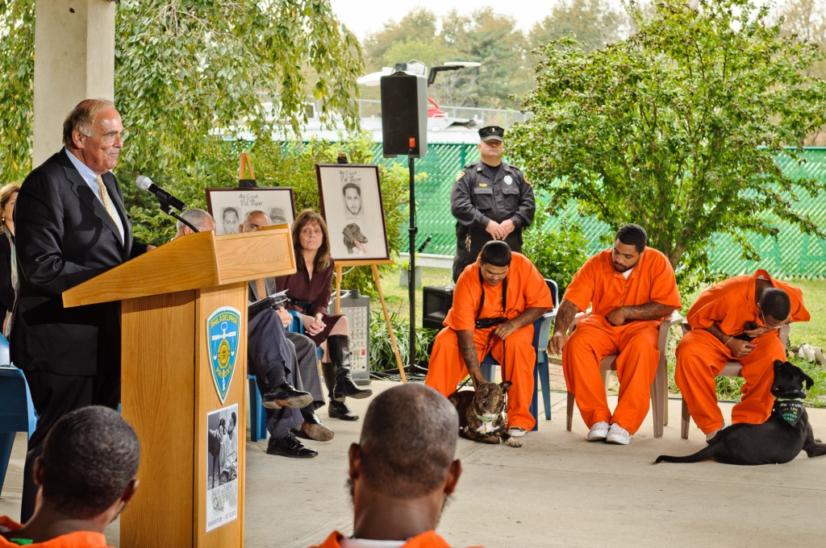

Officials of the Philadelphia Prison System, social agencies, advocates, prosecutors, defenders, and families were for this day united in sense of hope – and a sense of awe, I believe, about the power of the human canine bonds that had been created. The healing potential of this program was never more clear. A small touch of the feeling is captured in this picture of one graduate with “his” dog – showing spontaneous affection – ignoring momentarily all the “Important People” making speeches.

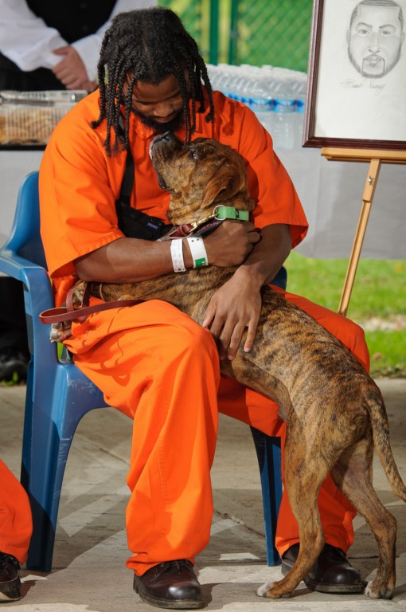
Dennis with Tyson at the Graduation

On that day, it all came down to this.

Lucas – “Least Likely to Succeed”

There were eight men selected for the first round of New Leash. Six completed the program.

One of the original participants was a very young man, 19 years old, named Lucas. Others involved in teaching and training, such as the Life Training Skills program, wanted him removed after the first day. He was inattentive, uncooperative, surly, and quite frankly frightening to the instructors.

New Leash refused to give up on Lucas.

From five different points of view, here is the story of Lucas, the “least likely to succeed,” in New Leash on Life’s first group. Lucas was paired with pit mix Paris Hilton.

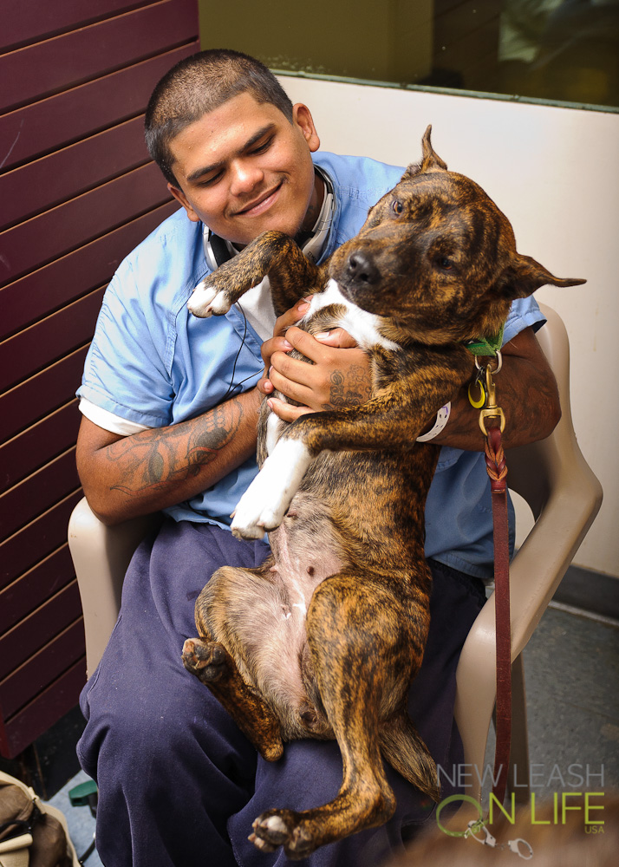

Lucas did not give up, either. As Marian recalls,

One of our guys, Lucas, was not the best student. He was very easily distracted, and I think didn’t really want to be part of the program, and didn’t connect with anybody, and was always distracted by whatever anybody else was saying, and it was a real effort to keep him motivated. Though I think he made the most progress as an individual, even though he didn’t do well in the group, he made the most progress if that makes sense. Because he was so, so low. But the last day we had training we were sitting in Mod 3 and I was sitting in the corner with Elvis the pit bull, and he came up to me and he said, “Can I sit with you?” And that was huge that he spoke first. It was like “Yeah, of course you can sit with me.” And he started talking to me about his life and about his daughter, and how much he liked the program, he told me his daughter is living with the baby-mama who wouldn’t let him see the baby very much. I don’t … I can’t…. describe all of this stuff, but then he went and he got a card, a birthday card, that had pictures of his baby on it. And he sat with me. That was enormous for him.

One of the Corrections Officers on the unit said this about Lucas:

At first we were told these were older gentlemen that are going to be up here taking care of dogs. Then we see young kids taking care of the dogs, and Lucas is about the youngest. You know what – I’ve seen a lot of change in that kid. A lot of people haven’t seen a change in him because other C.O.s are different, they’re judging them personally, just by the way their appearance are, not who they are inside. That kid, yeah, he’s got a strong heart you know, but they don’t see that because they don’t talk to them like they talk to me and none of them talk to these guys like they talk to me.

Nicole says,

Lucas wanted to adopt Paris. And Lucas was hard, because he was a guy that just completely shut down. Until the end, when he actually had to do it on his own. [His training partner was taken out of the program near the end, so Lucas had to continue with the training of Paris Hilton by himself.] That was the best thing that could've happened to him. Once he had to do it on his own, and was going to be held accountable for it, he didn't want to fail - really he didn't want Paris to fail. He didn't want his dog to fail. He was in love with that dog. By the time of graduation, he was so attached to Paris. He did love that dog at the end. At the beginning, he didn’t care about anything, I mean, anything.

Laura adds,

I think Lucas from the first group was, I mean, the kid's maniacal. You could just see him on the magazine like New York Times cover serial killer, and I hear he's doing really, really well at ACCT. . He has a mentor, a Latino guy that was incarcerated, who has kind of taken him under his wing. You saw his parents at graduation. He has two daughters and he's 19.

Rob, who provided a post-release internship placement for Lucas at the Animal Care & Control Team facility, summarizes:

Well, he was here and he interned for me. And he did a great job. He came in and he was treated as an employee during his internship. So every rule and policy and protocol that was in place. He had to follow and he was very obedient to the rules and regulations. He claimed really well and he socialized pretty well with the staff. He was here 30 days on that internship and now he's coming back in few days. And it's just a matter of an interview with my co-shelter manager and the director. We’ll just be talking about how we’re going to move forward.

If you want to ask me whether every man is going to be saved by the program, well, not every man will be saved. That's too high of a goal to expect. But if we can save one, one of those men, and put them to work, and become a productive member of the society. That's one less person that we have to worry about committing crimes and hurting people.

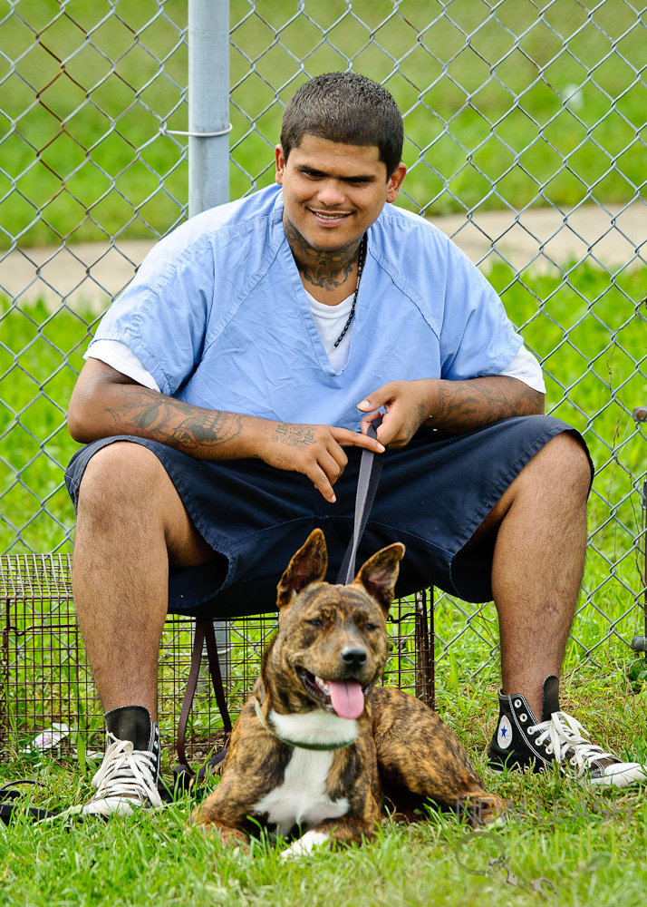

Lucas accepted a 30 day internship with Rob Rosa at the Animal Care and Control Team facility. He showed up on time, and got along with other workers.

As we write this, Lucas is about to come back to the shelter and be interviewed by Rob and his colleagues – for a paid job.

Interviews aren’t easy for men in Lucas’ life situation. They’re threatening, judgmental, too much like the whole web of being controlled. We wish him luck.

Rob went through all this, about seven years ago. Now he has a solid job, just bought a house, and has a family – including a young daughter.

No one knows how this will turn out for Lucas, but Rob is on his side. That’s a mighty good thing.

Personally, I hope all of America is on his side.

Stay tuned.

References

D’Amore, M. D. (1976). Introduction. In R. T. Arcangelo & M. D. D’Amore (Eds.), William Alanson White, the Washington years 1903-1937 (pp. 2-3). Washington, DC: U.S. Government Printing Office.

Furst, G. (2006). Prison-based animal programs: a national survey. The Prison Journal, 86(4), 407-430.

Strimple, E. O. (2003). A history of prison inmate-animal interaction programs. American Behavioral Scientist, 47(1), 70-78.

Strimple, E. O. (2003). A history of prison inmate-animal interaction programs. American Behavioral Scientist, 47(1), 70-78.
There was one, in the middle part of the last decade, but that’s gone now. More about that later.
Two men were taken out of the program midway because of a rule infraction during leave on a day pass.
http://www.build.acctphilly.org/
http://en.wikipedia.org/wiki/Incarceration_in_the_United_States
From the Latin word “recidivus” from re = back and cado = I fall.
Now promoted to Chief of Staff
Ulie is one of those near-magical dogs – able to take dozens or hundreds of commands, with eyes as insightful as any human’s.
The Alternative Sentencing & Detention unit, or ASD, was the location for the first round of New Leash work.
Strimple, E. O. (2003). A history of prison inmate-animal interaction programs. American Behavioral Scientist, 47(1), 70-78.
Furst, G. (2006). Prison-based animal programs: a national survey. The Prison Journal, 86(4), 407-430.
Two were given a day pass, and made some mistakes that got them ejected from the program. One of those two has now been readmitted to the second round of New Leash.

